WEEK 1:

* Statistics: the study of the *collection*, *analysis*, and i*nterpretation* of data.
* Data professionals use stats to predict:
* Future sales revenue
* The success of a new ad campaign
* The rate of return on a financial investment
* The number of downloads for a new app
* Econometrics: a branch of economics that uses stats to analyze economic problems.

**The role of statistics in data science**

* Data professionals use stats to analyze data in : *business,* *medicine, science, engineering, government.*
* Data professionals use stats methods to:
* Identify meaningful patterns and relationships in data
* Analyze and quantify uncertainty
* Generate insights from data
* Make informed predictions
* Solve complex problems
* Stats concepts:
* Probability: likelihood of an event (ex: weather report)
* Average: sports stats
* Margin of error: election poll
* Percentile: doctors
* Median: doctors
* A data professional use probability to:
* **Predict** the future rate of return on investment
* Estimate the annual **avg** sales revenue
* Calc the **margin of error** to quantify the uncertainty of an employee satisfaction survey
* Use **percentiles** to rank median home prices in different cities

**Statistics in action: A/B testing**

* A/B testing: a way to compare 2 versions of sth to find out which version performs better.
* Marketing emails
* Online ads
* A/B test steps:
* **Analyze a small group of users**

Sample: a subset of the larger population

Inferential stats: make inferences about a dataset based on a sample of the data

(Thống kê suy diễn: đưa ra suy luận về một tập dữ liệu **dựa trên một mẫu** của dữ liệu)

* **Decide on the sample size**

Confidence interval: a range of values that describes the uncertainty surrounding an estimate

(Khoảng tin cậy: một phạm vi giá trị mô tả sự **không chắc chắn** xung quanh một ước lượng.)

* **Determine the stats significance**

Stats significance: the claim that the results of a test or experiment are not explainable by chance alone

(Ý nghĩa thống kê: khẳng định rằng kết quả của một bài kiểm tra hoặc thí nghiệm **không thể giải thích chỉ bằng yếu tố ngẫu nhiên**)

**Descriptive statistics versus inferential statistics**

* descriptive statistics: describe or summarize the main features of a dataset
* forms:
* visuals, like graphs and tables: histograms, scatter plots, box plots.
* summary stats: summarize data using a single number.
* Measures of central tendency: describe *the center* of dataset (ex: the mean)
* Measures of dispersion: describe the *spread of dataset*, or the amount of *variation* in data points (ex: standard deviation)
* Inferential stats: make inferences about a dataset based on a sample of the data
* Population: every possible element that you are interested in measuring
* Sample: a subset of the larger population
* Stats population: people/ objects/ events
* Representative sample: a sample that accurately reflects the population
* Parameter: a characteristic of a population
* Stats: a characteristic of a sample.

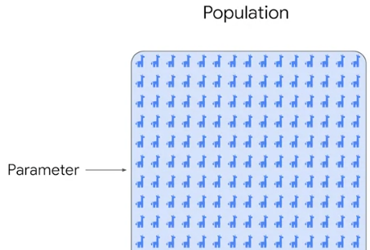 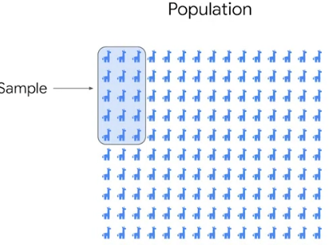

**Measures of central tendency**

* Measure of central tendency: values that represent the center of a dataset
* Mean: the average value in a dataset

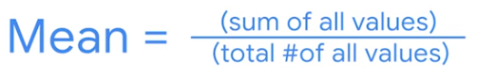

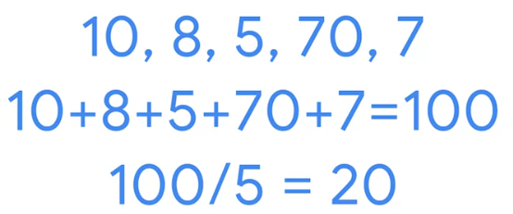

* Median: the middle value in a dataset

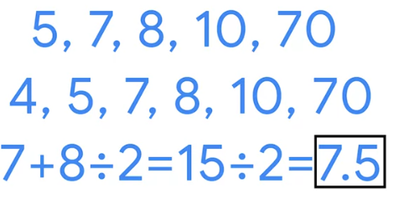

**<!!!>** when to use MEAN or MEDIAN:

* If outliers, use MEDIAN
* If no outliers, use MEAN

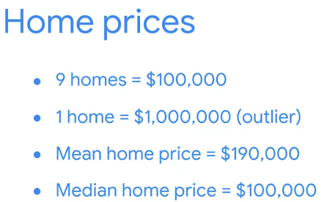

* Mode: the most frequently occurring value in a dataset
* A dataset can have no mode, one mode, or more than one mode

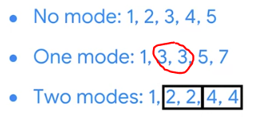

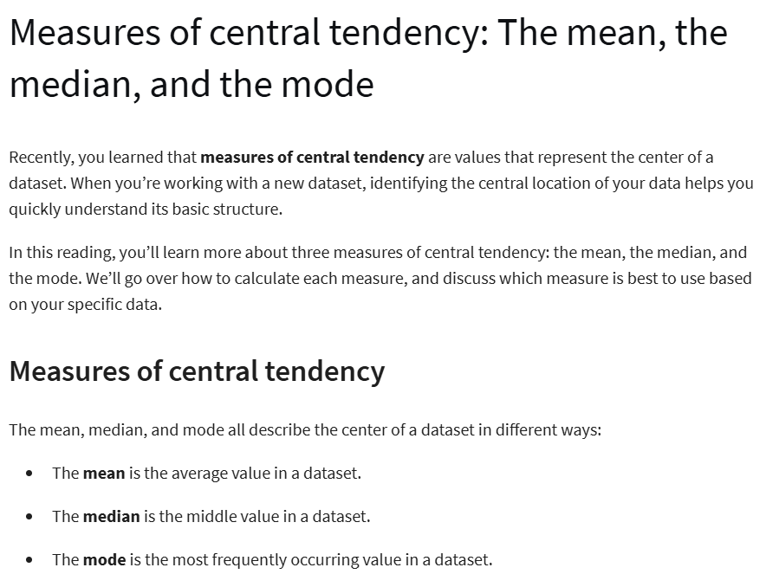



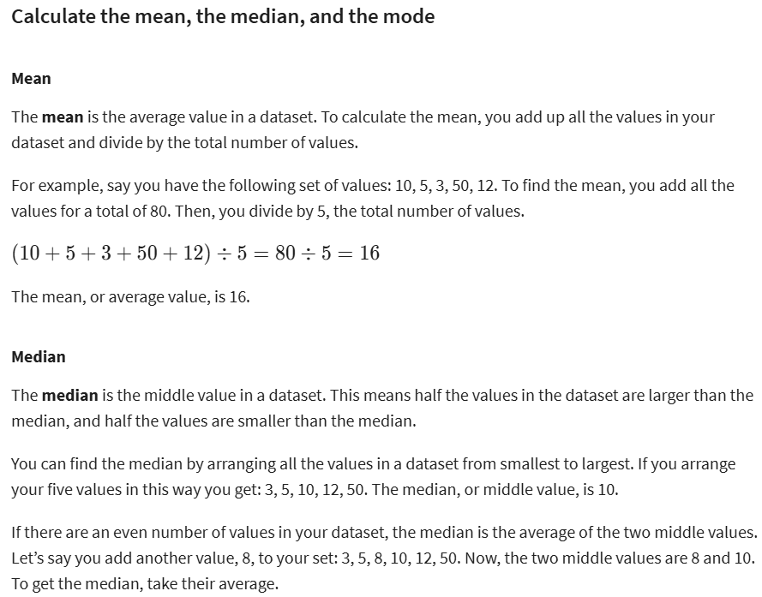



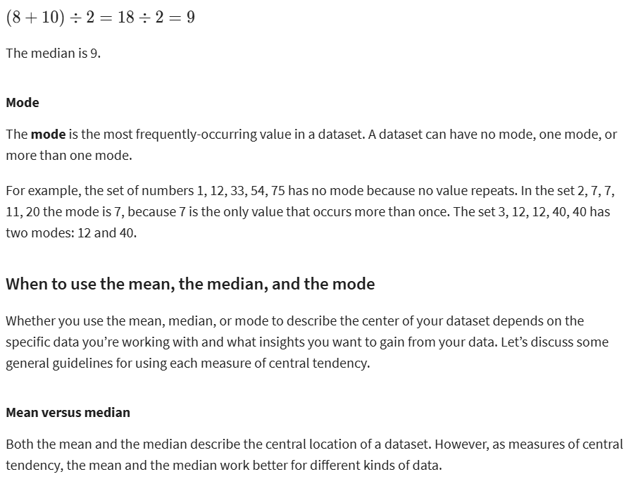



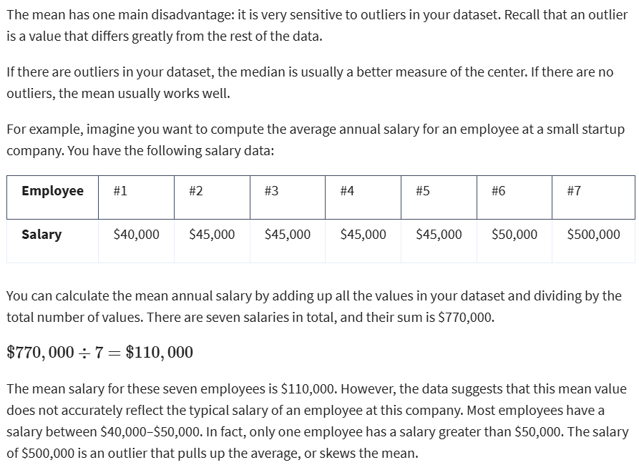



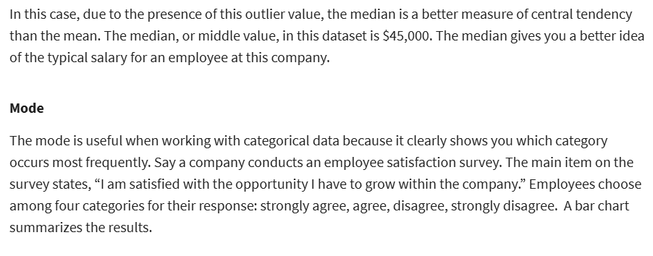



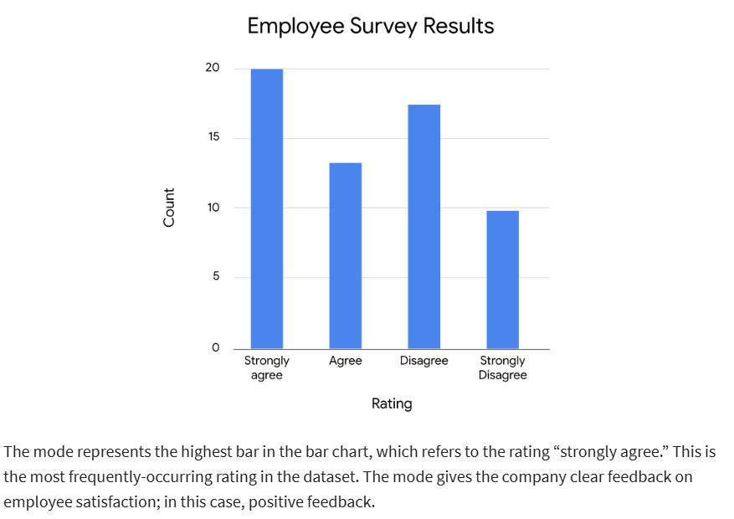

**Measure of dispersion:**

* Range: the difference between the largest and smallest value in a dataset
* Standard deviation: measure how spread out your values are from the mean of your dataset.
* The larger std deviation, the more spread out your values from the mean.

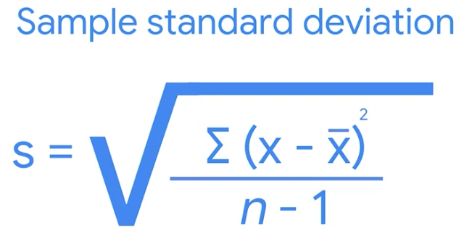

* Variance: the average of the squared difference of each data point from the mean

**<!!!>** It’s the square of deviation

* Data professionals use std deviation to measure variation in:
* Ad revenues
* Stock prices
* Employee salaries

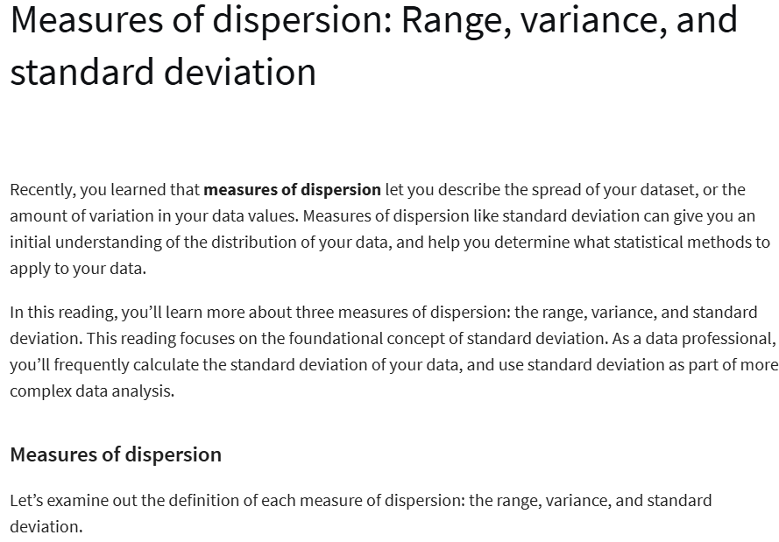



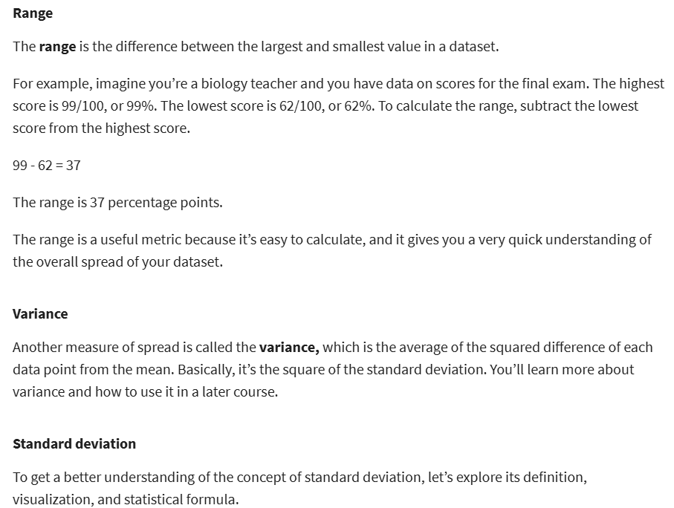



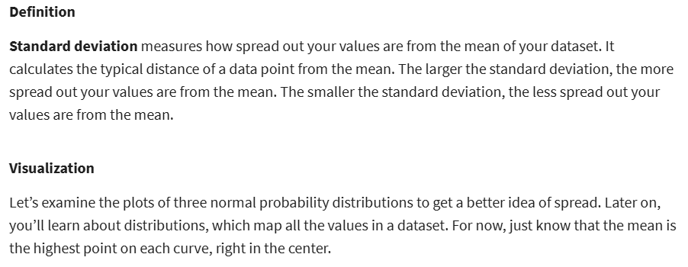



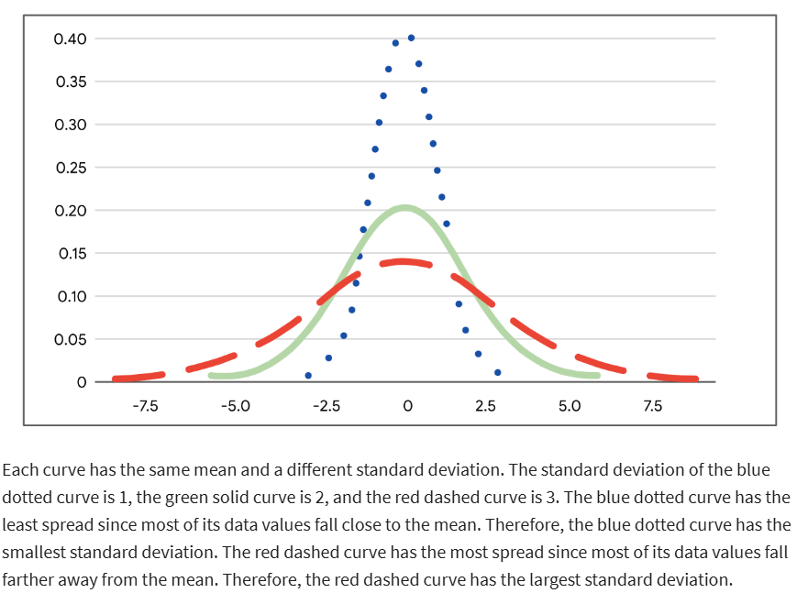



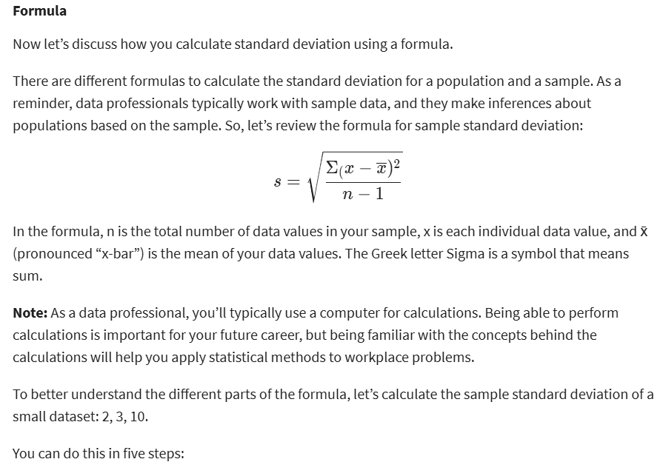



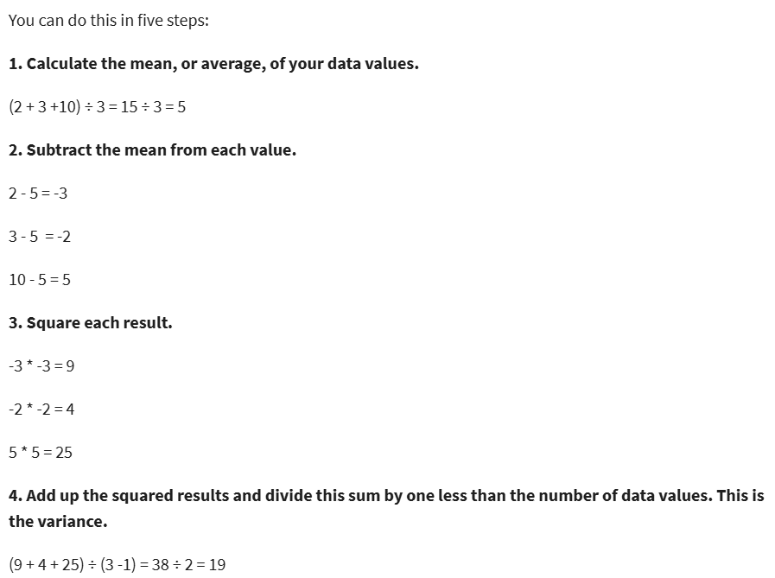

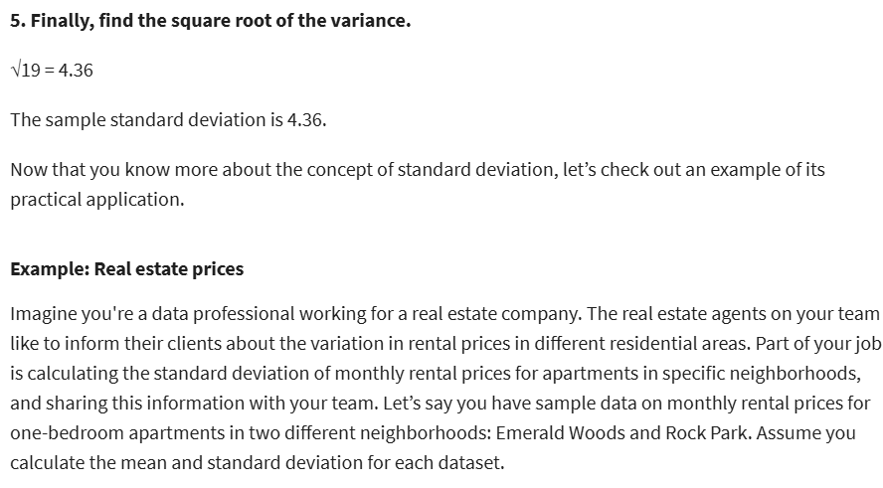

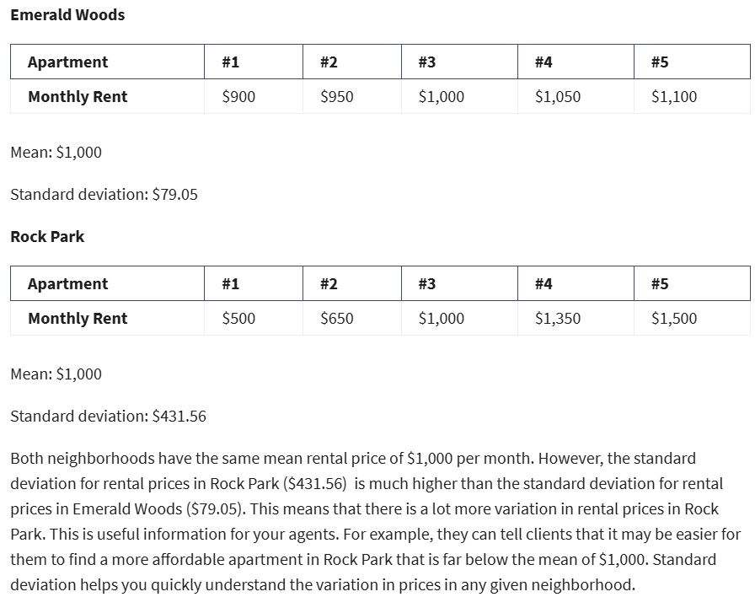

**Measures of position:**

* Measures of position: determine the position of a value in relation to other values in a dataset
* Percentiles (Phân vị)
* Quartiles (Tứ phân vị)
* Interquartile range
* Five number summary
* Percentile: the value below which a percentage of data falls. Divides the values in a dataset into 100 equal parts.

(Phân vị: giá trị mà dưới đó một phần trăm dữ liệu nằm)

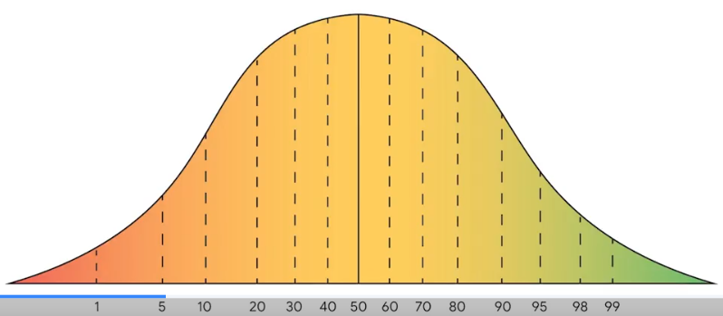

* Quartile: divides the values in a dataset into four equal parts
* 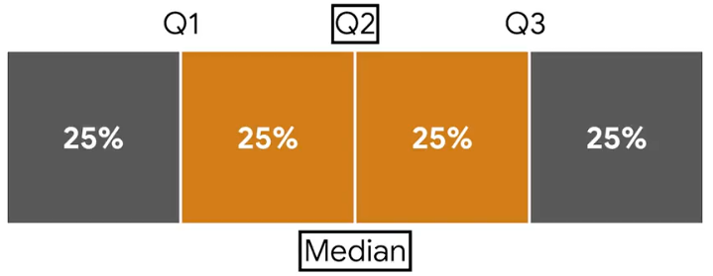

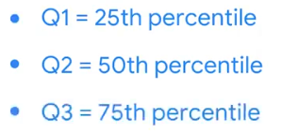

* Interquartile range (IQR): the distance between the first quartile (Q1) and the third quartile (Q3). It indicates the spread of the **middle half** or the middle 50% of your data.
* Data prof use measures of position to better understand:
* Public health data: life expectancy
* Macroeconomic data: household income
* Business data: product sales

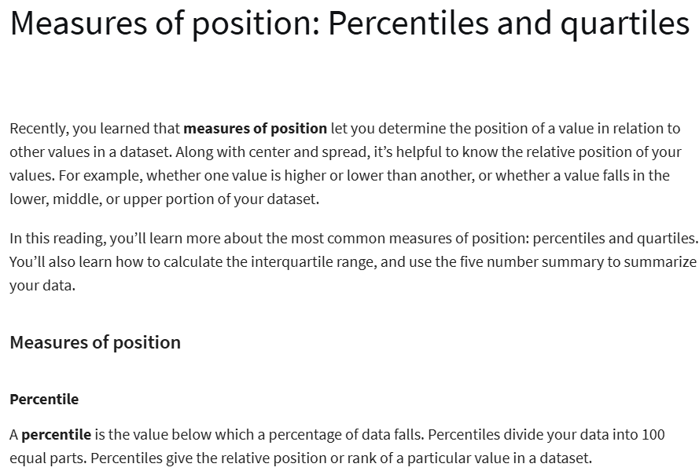



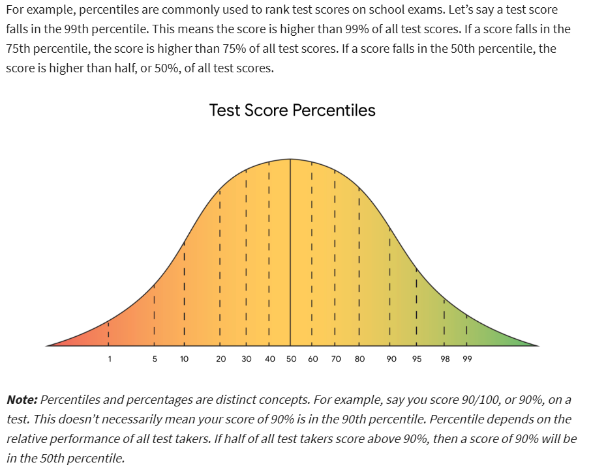



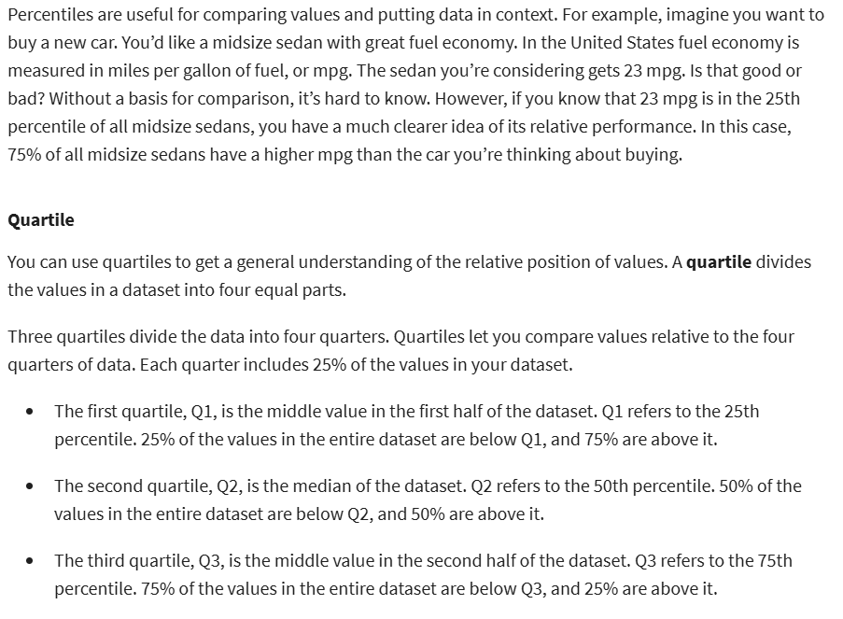



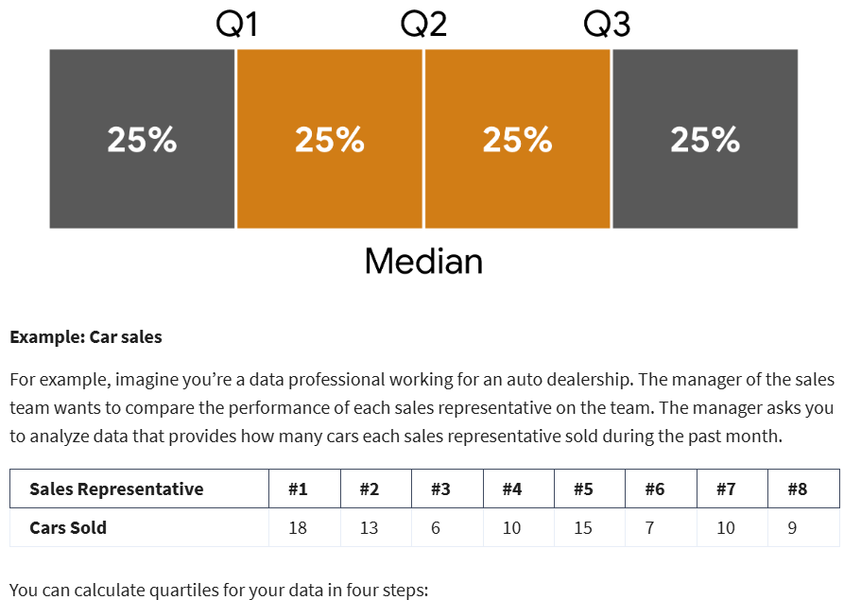

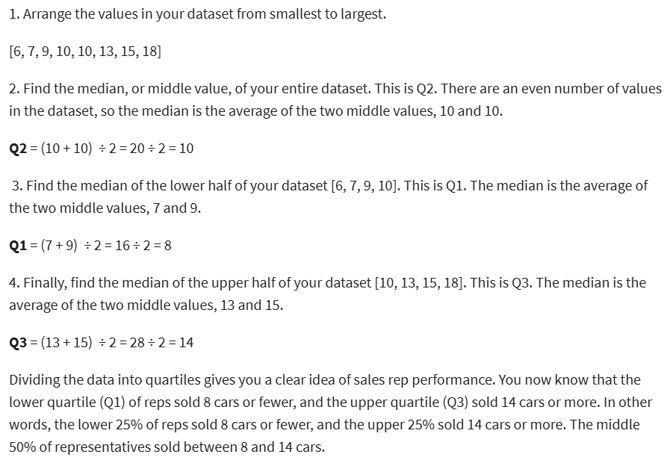

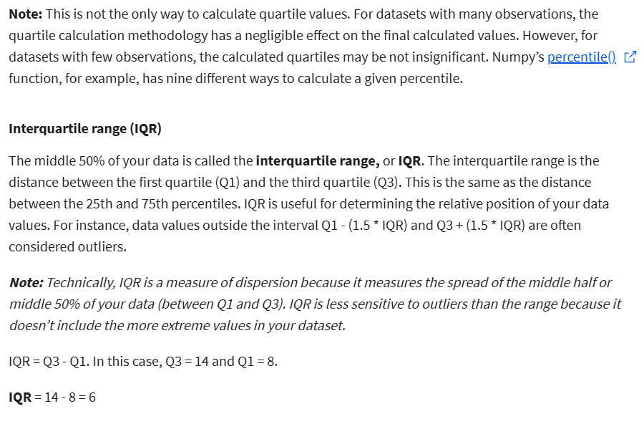

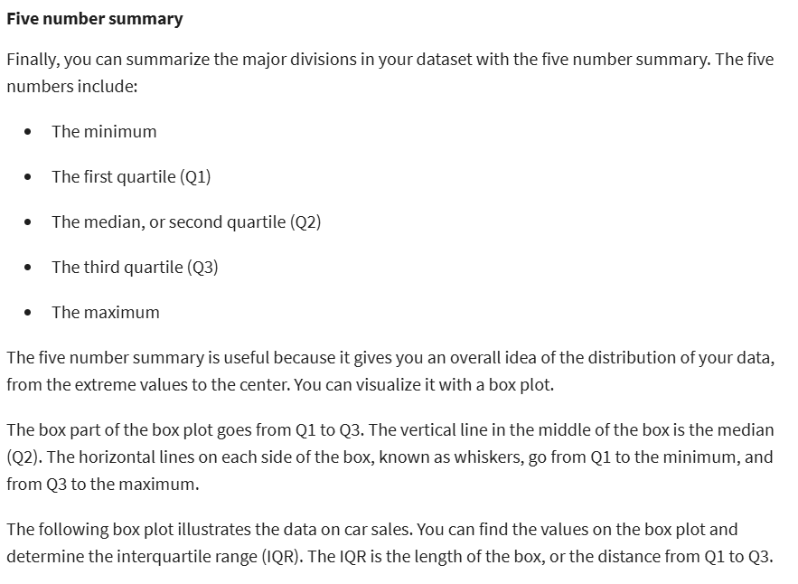



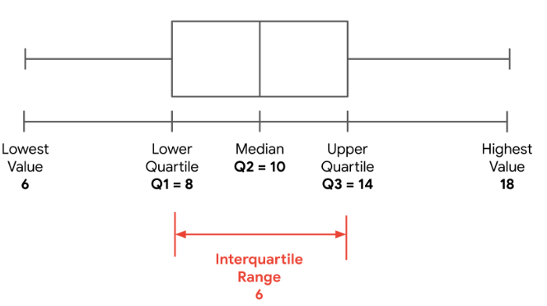

**Compute Descriptive Stats with Python**

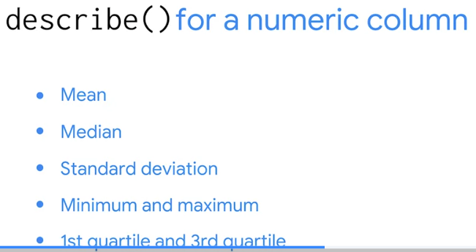 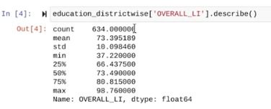

* For more details: <https://www.coursera.org/learn/the-power-of-statistics/lecture/66jFw/compute-descriptive-statistics-with-python>

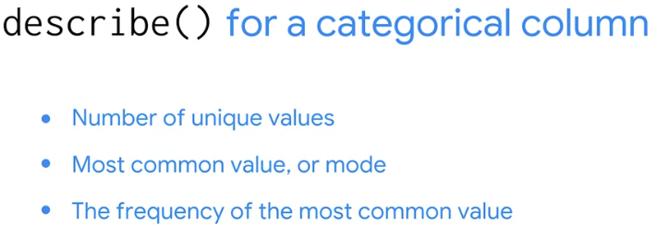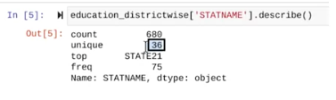

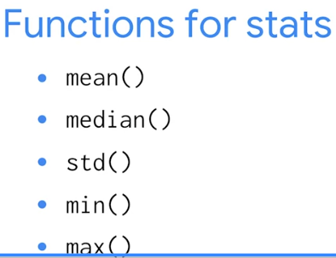



End of WEEK 1……………

WEEK 2:

**Objective vs. Subjective probability**

* Probability use cases:
* A company will sell a certain amount of product in a given time period
* A financial investment will have a positive return
* A political candidate will win an election
* A medical test will be accurate
* Objective prob: based on stats, experiments, and mathematical measurements
* Subjective prob: based on personal feelings, experience, or judgment
* Objective prob:
* Classical: based on formal reasoning about events with *equally likely* outcomes. Ex: flip coin, withdraw cards.

(Lý thuyết cổ điển: dựa trên lý luận chính thức về các sự kiện với các kết quả **có khả năng xảy ra như nhau**)



* Empirical: based on experimental or historical data. Ex: weather



* Data prof use sample data to make inferences or predictions about larger populations.

**<!!!>** data prof rely on EMPERICAL prob to help them **make accurate** **predictions** based on sample data.

**The principles of probability:**

* Events in probability:
* If the probability of an event equals 0, there is a 0% chance that the event will occur
* If the probability of an event equals 1, there is a 100% chance that the event will occur
* If the probability of an event is close to 0, there is a small chance that the event will occur
* If the probability of an event is close to 1, there is a strong chance that the event will occur
* Probability measures the likelihood of random events

(Xác suất: đo lường **khả năng xảy ra của các sự kiện ngẫu nhiên**.)

* Random experiment: a process whose outcome cannot be predicted with certainty. Ex: flipping coin
* The experiment can have **more than 1 possible outcome**
* You can represent each possible outcome **in advance**
* The outcome of the experiment d**epends** **on chance**

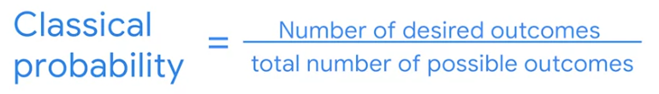

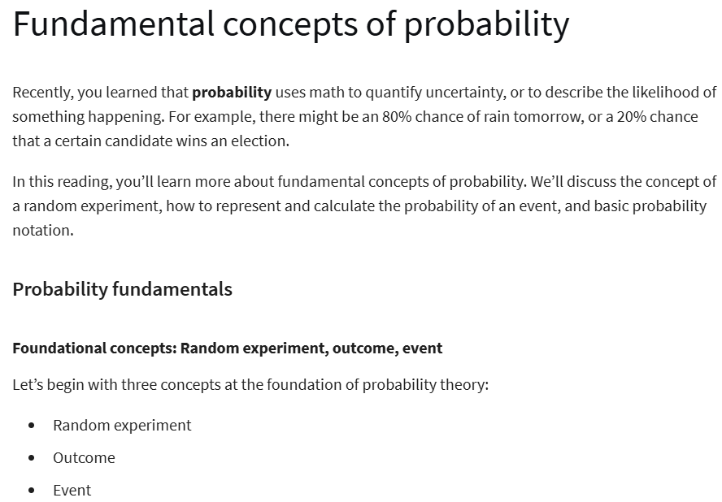



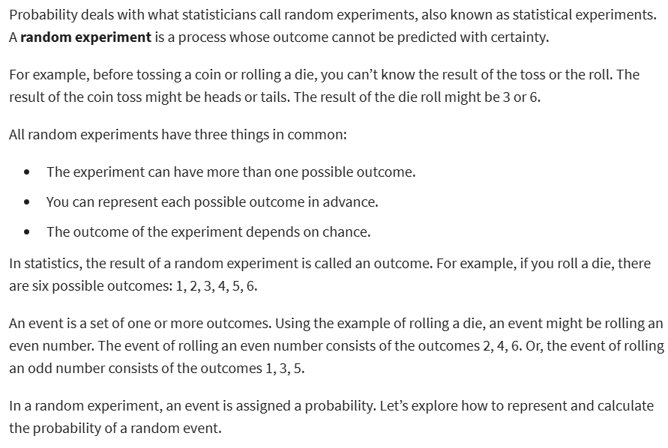



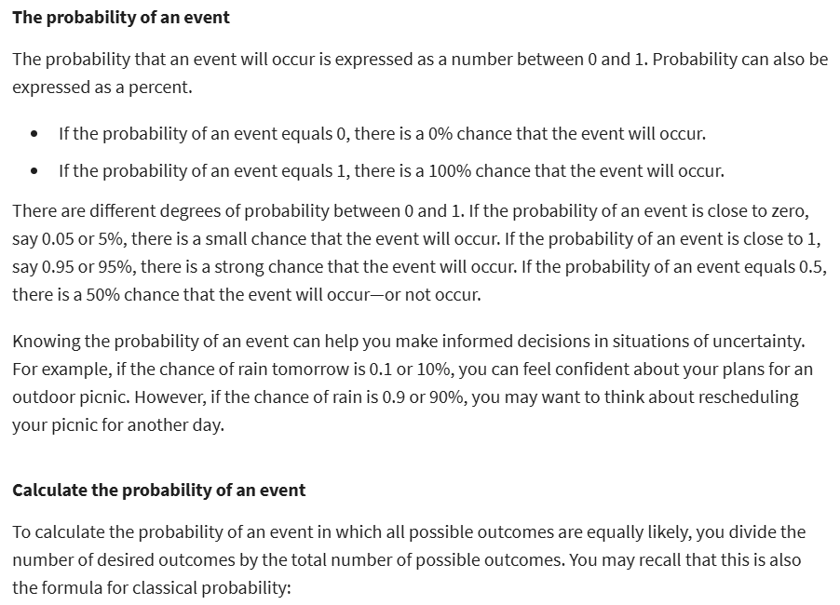



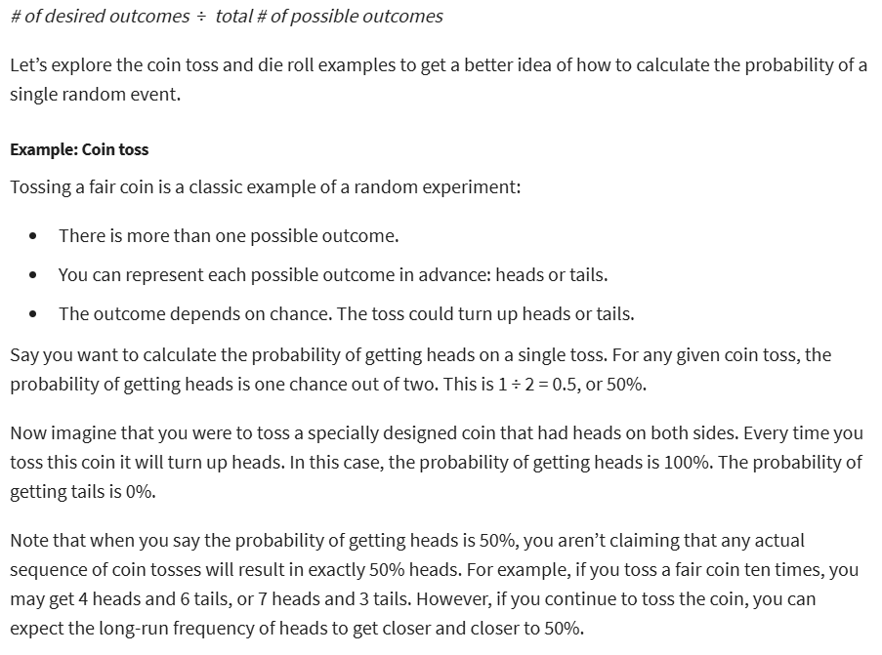



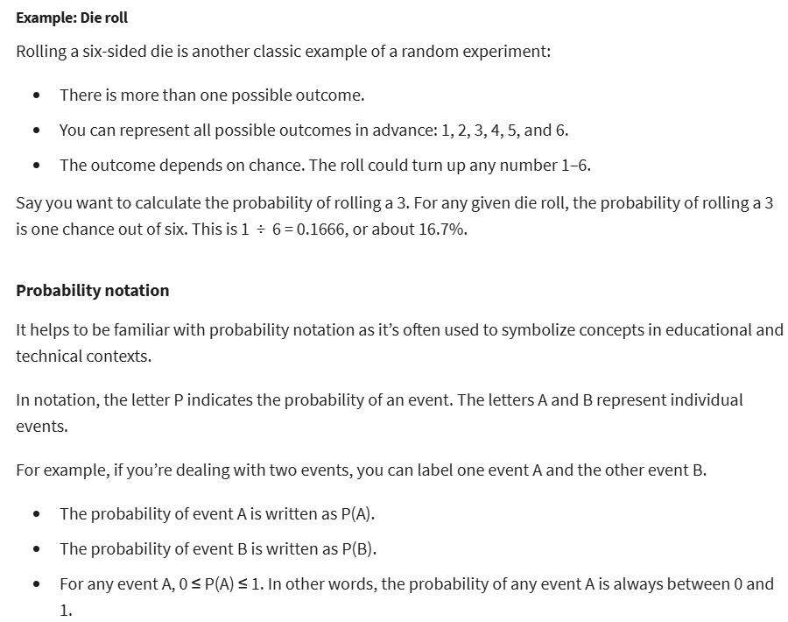

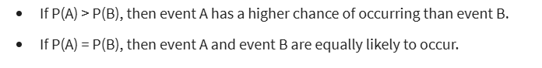

**The Basic Rules of Probability and Events:**

* Complement rule
* Addition rule
* Multiplication rule
* Probability notation:
* P(A) = probability of event A
* P(B) = probability of event B
* P(A’) = probability of **NOT** event A
* Complement of an event: the event not occurring (ex: rain or doesn not rain, win lottery or not win)

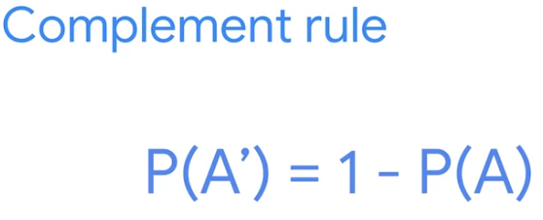

* Mutually exclusive events: 2 events are mutually exclusive if they cannot occur at the same time. (ex: turn left n right at the same time)

(Các sự kiện loại trừ lẫn nhau: Hai sự kiện được coi là loại trừ lẫn nhau nếu chúng **không thể xảy ra cùng một lúc**.)

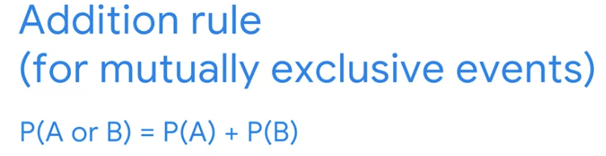

* Independent events: 2 events are independent if the occurrence of 1 event does not change the probability of the other event.

(2 su kien dien ra doc lap)

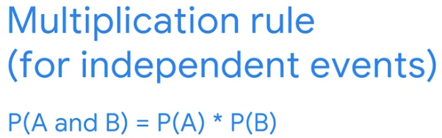

<!!!> **Addition rule** applies to mutually exclusive events.

**Multiplication rule** applies to independent events.

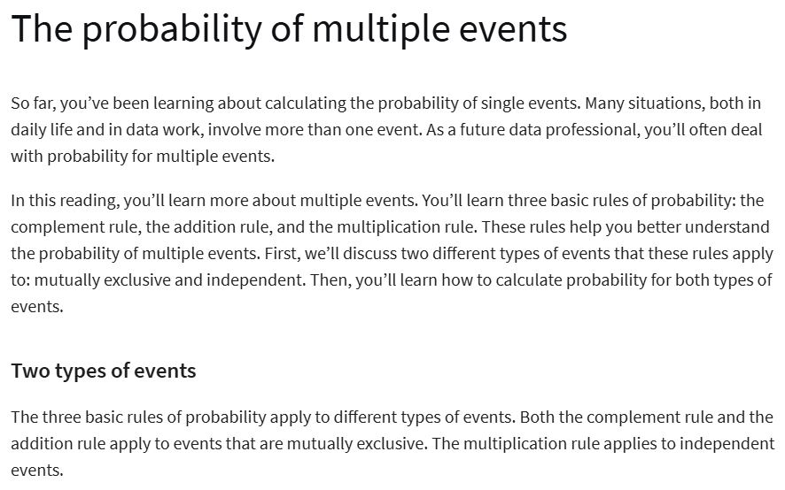

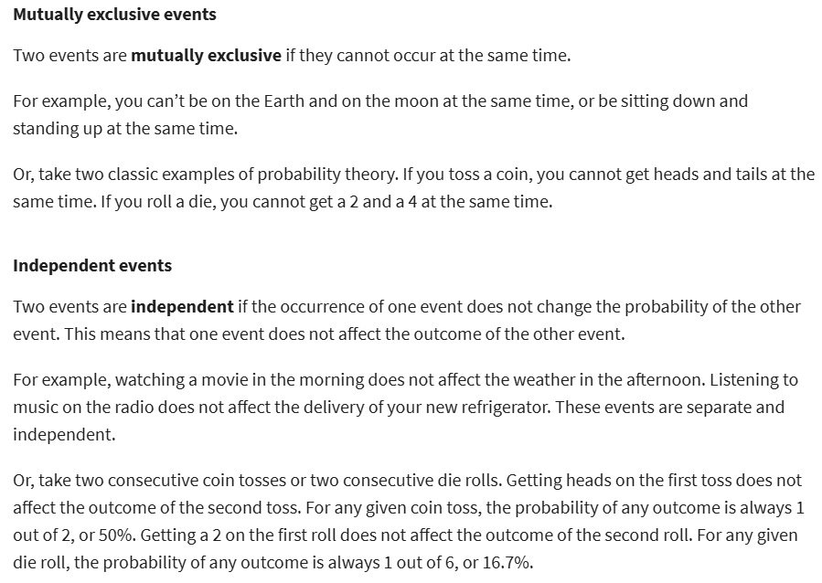



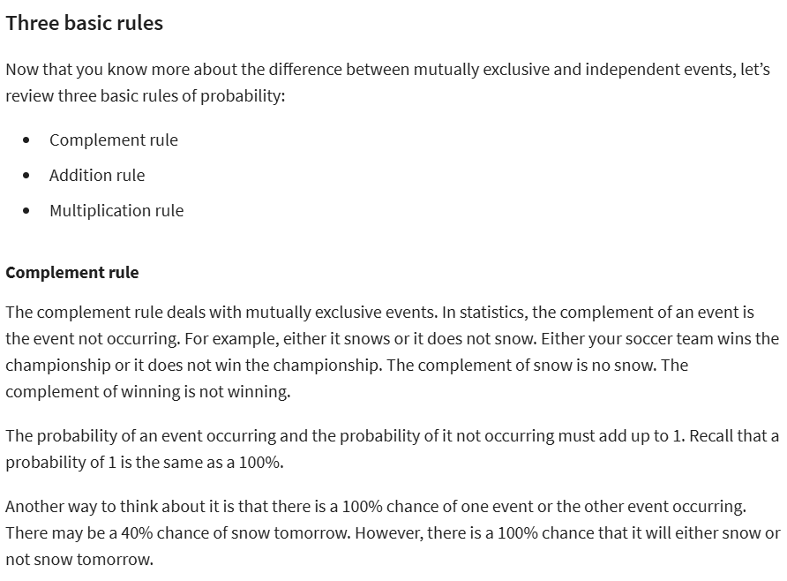



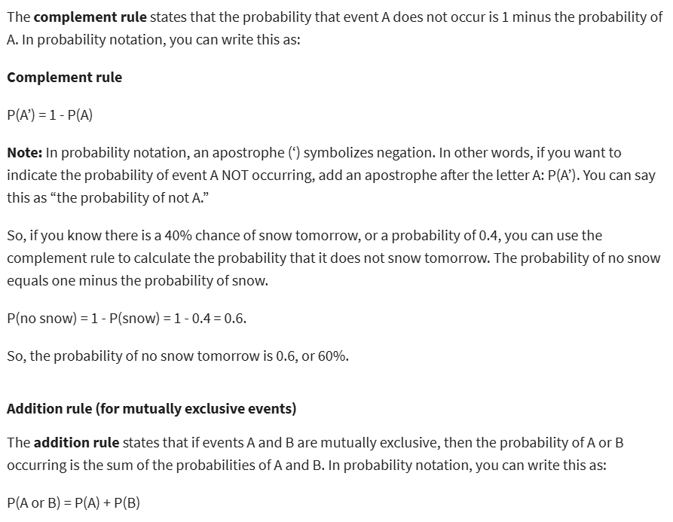

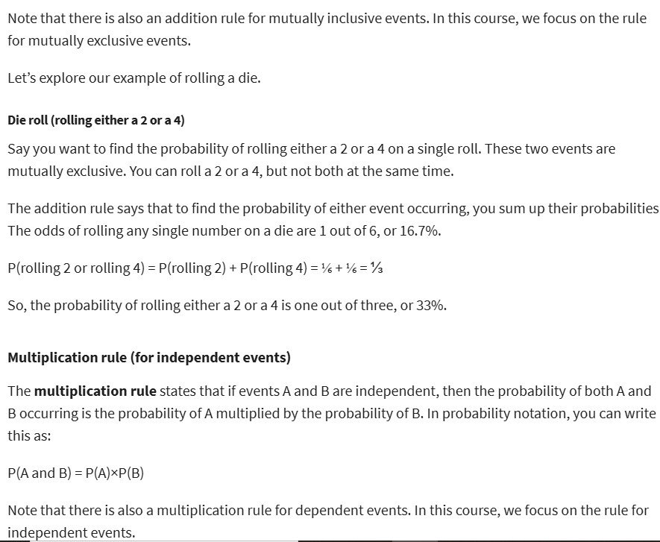

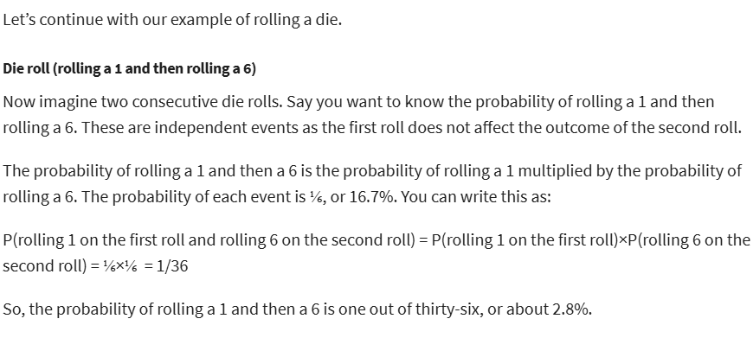

**Conditional probability:**

* conditional probability: the probability of an event occurring given that another event has already occurred.

(Xác suất điều kiện: xác suất của một sự kiện xảy ra, given (giả sử) rằng **một sự kiện khác đã xảy ra trước đó**.)

* Dependent events: 2 events are dependent if the occurrence of 1 event changes the probability of the other event.

(Các sự kiện phụ thuộc: Hai sự kiện được coi là phụ thuộc nếu sự xảy ra của **một sự kiện làm thay đổi xác suất của sự kiện còn lại**.)

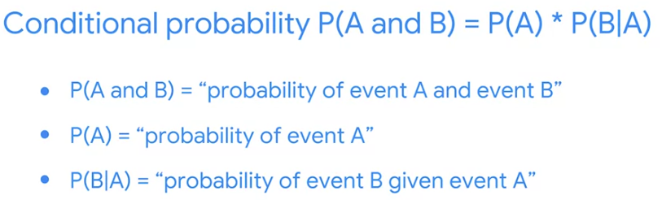

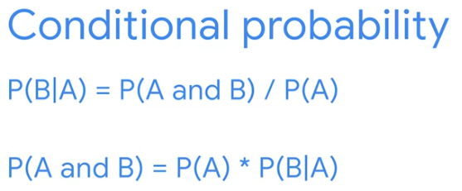

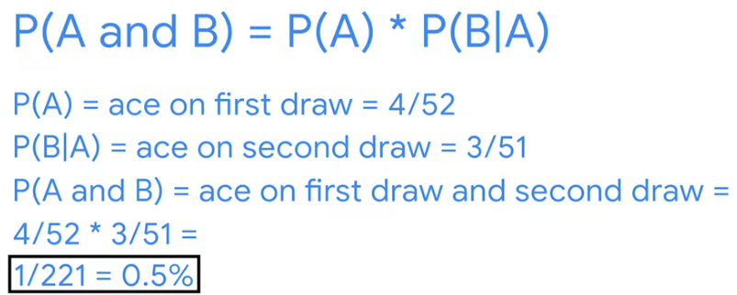

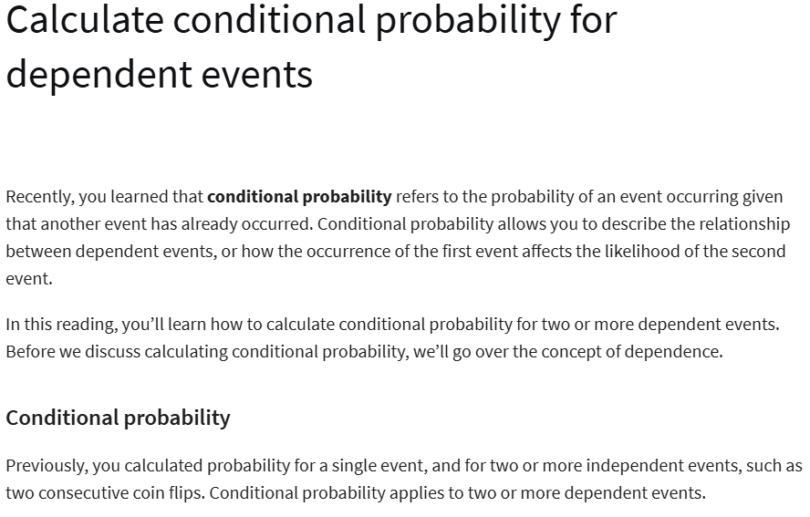

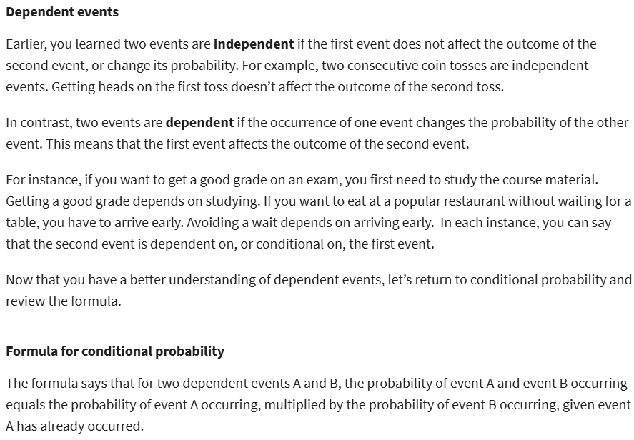

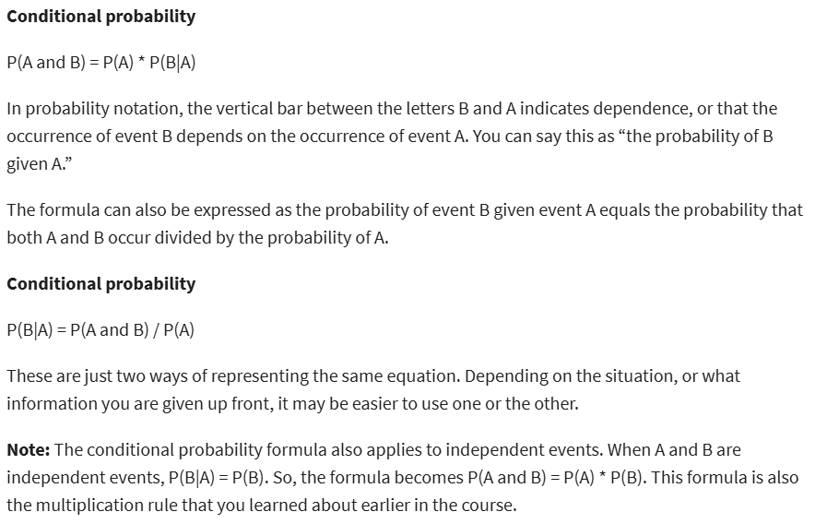

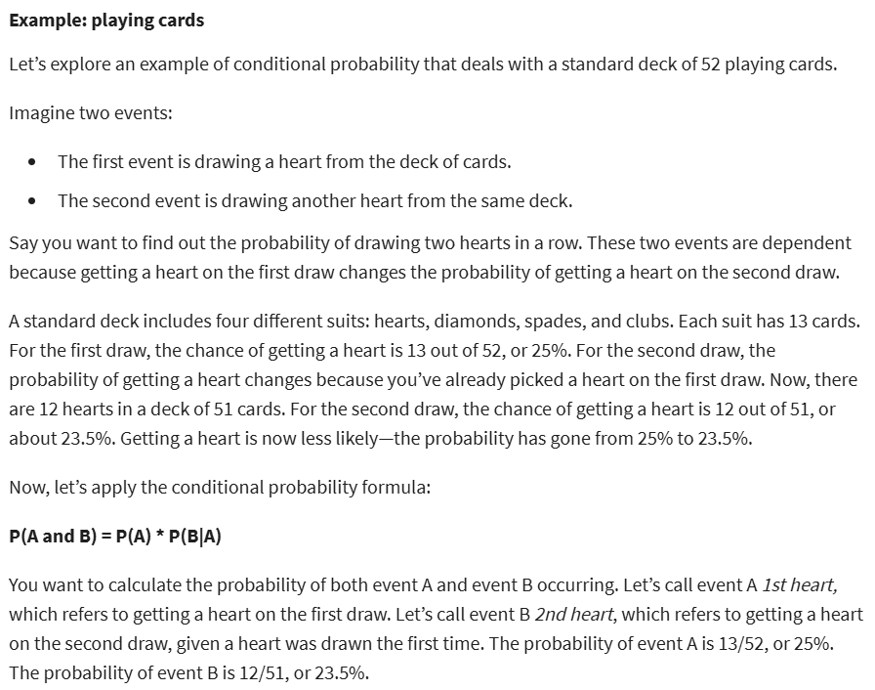

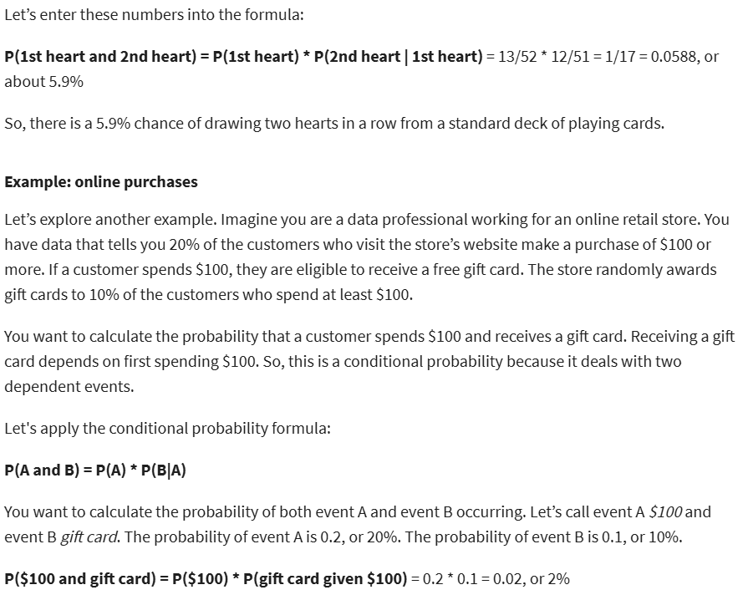



**Discover Bayes’ theorem:**

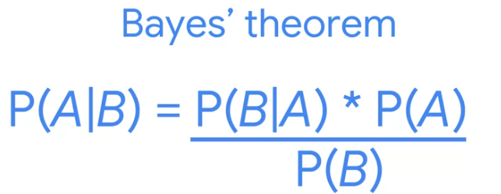

* Prior probability: the probability of an event before new data is collected.
* Posterior probability: **(occurring after)** the updated probability of an event based on new data.
* Bayesian stats (Bayesian inference): a powerful method for analyzing and interpreting data in modern data analytics.

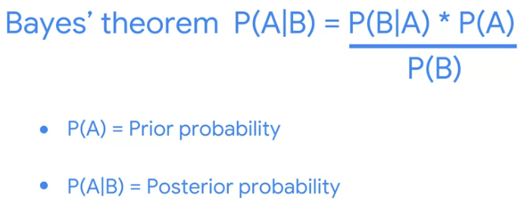

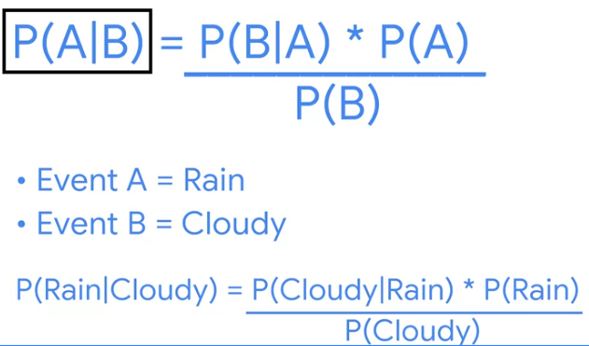

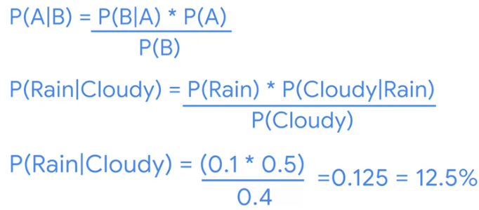

**The expanded version of Bayes’s Theorem:**

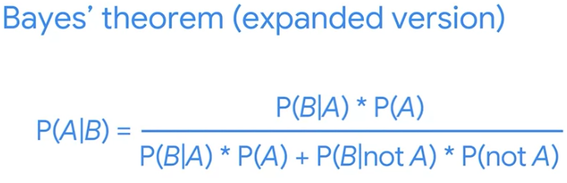

* Used:
* Medical diagnostic tests
* Quality control tests
* Software tests
* False positive: test result that indicates sth is present when it really is not.

(Duong tính giả: kết quả kiểm tra cho thấy cái gì đó **có mặt** khi **thực tế nó không có**)

* False negative: test result that indicates sth is NOT present when it really is.

(Am tính giả: kết quả kiểm tra cho thấy cái gì đó **không có mặt** khi **thực tế nó có**)

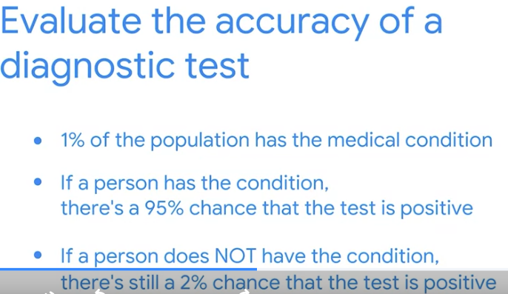

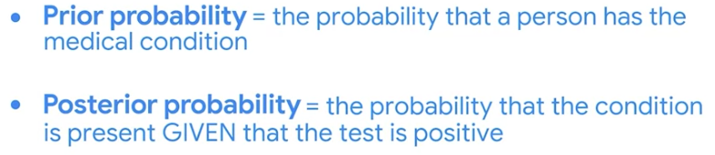

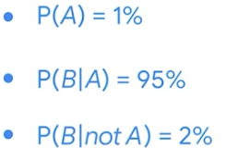

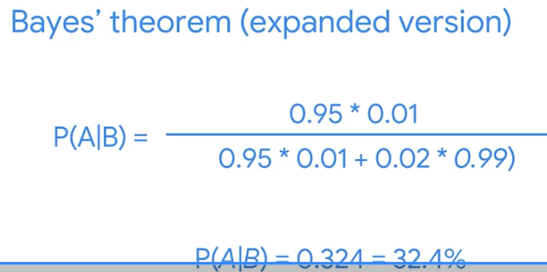

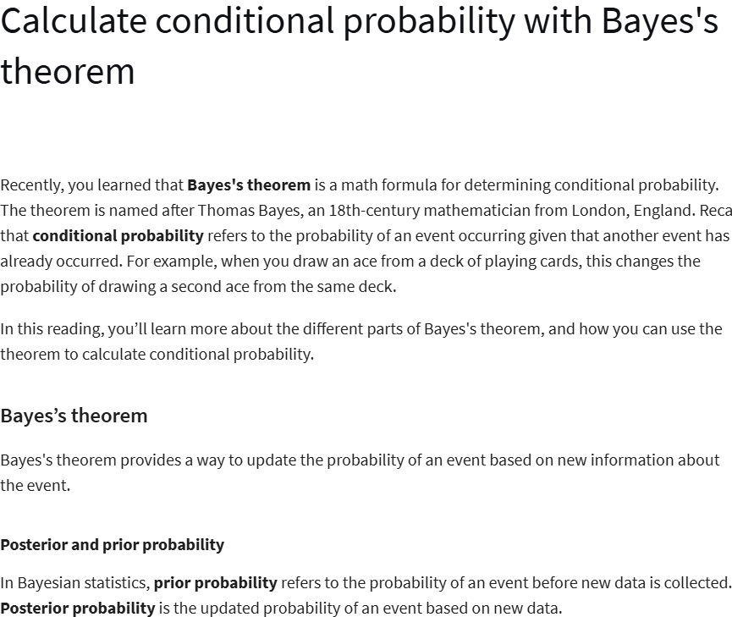

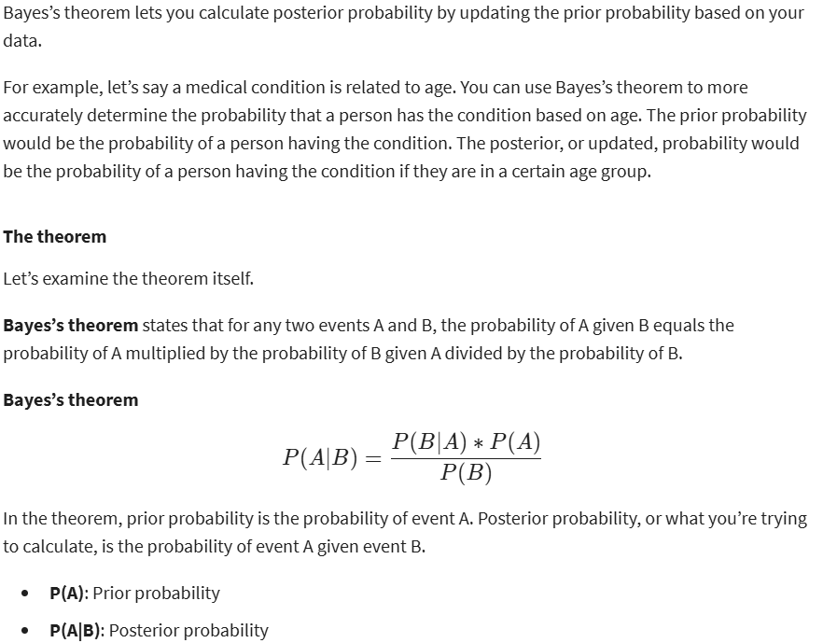

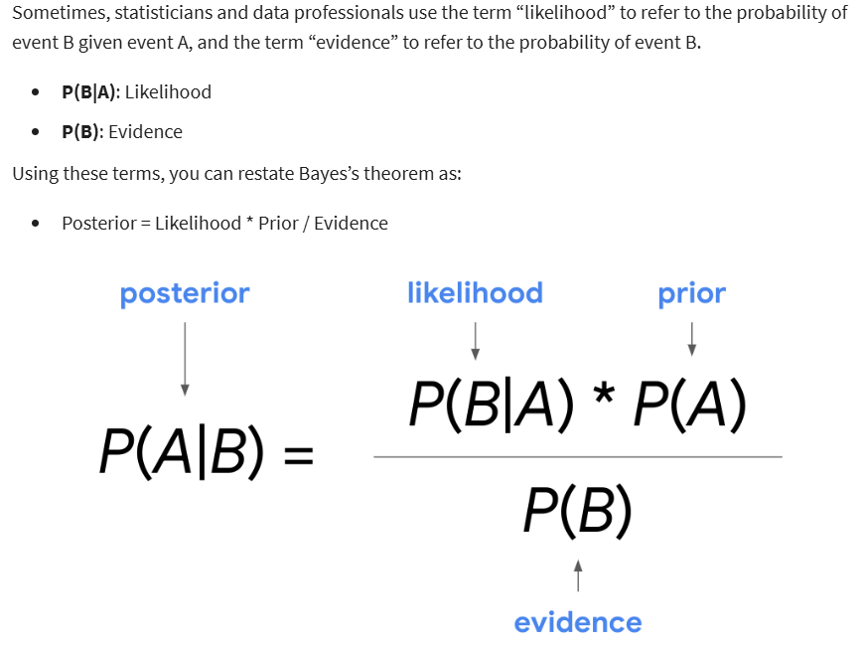

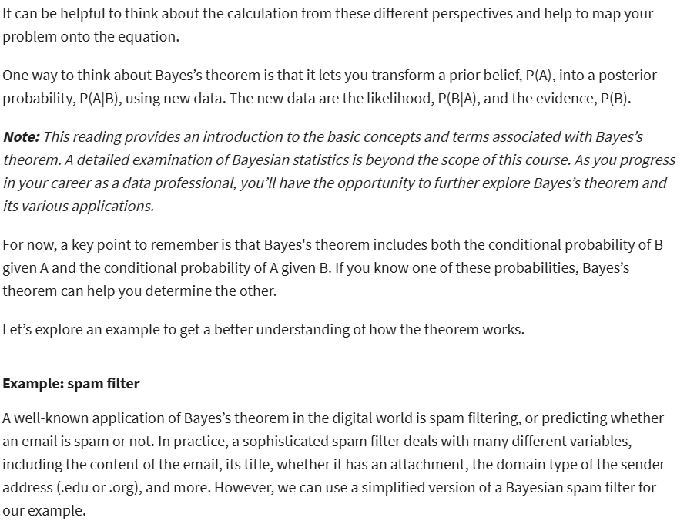



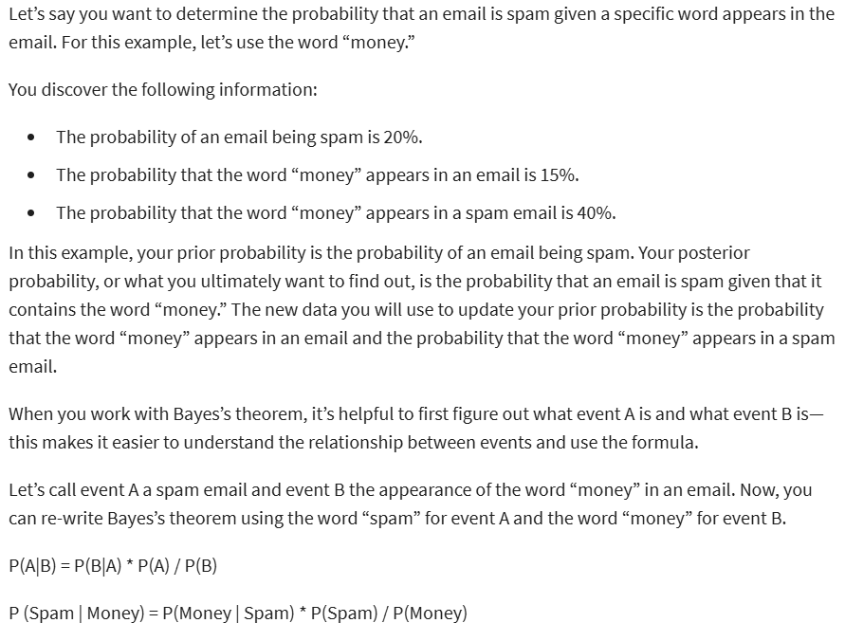

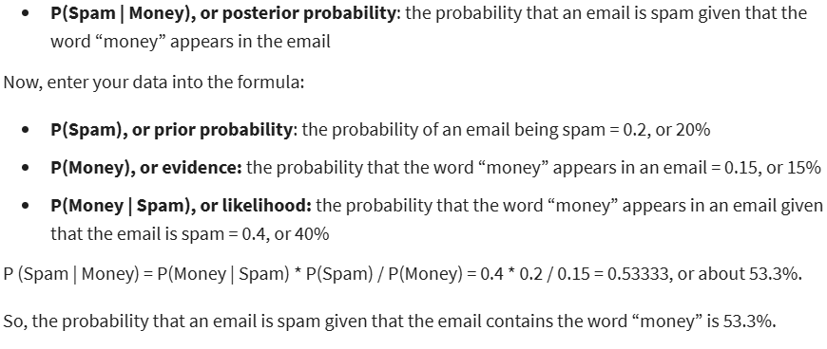

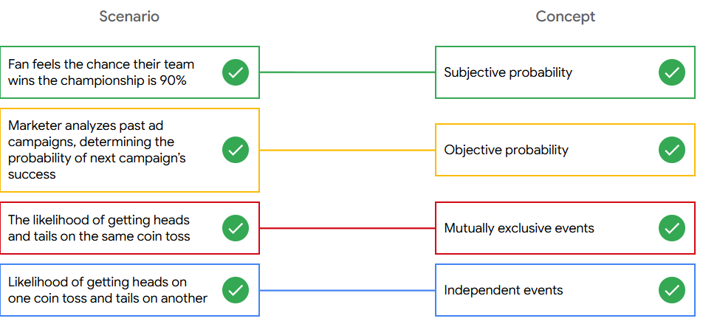

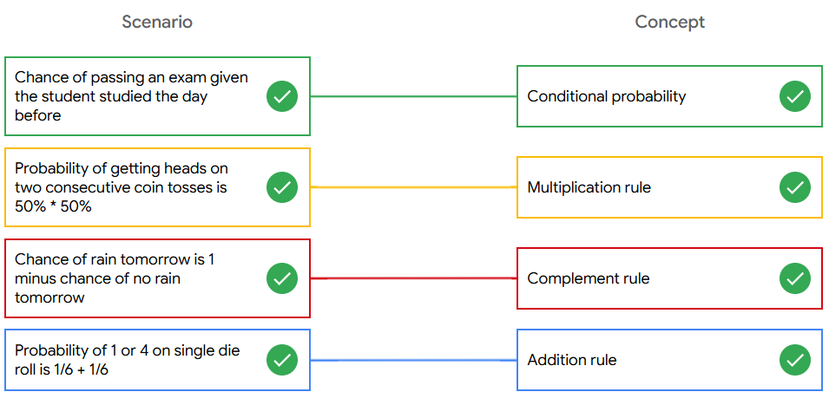

**Introduction to probability distribution:**

* Probability distribution: describes the likelihood of the possible outcomes of a random event.

(Phân phối xác suất: mô tả **khả năng xảy ra** của các **kết quả** có thể của một **sự kiện ngẫu nhiên)**

* Random variable: represents the values for the possible outcomes of a random event.
* Discrete
* Continuous
* Discrete Random Variable: has a countable number of possible values
* Continuous Random Variable: takes all the possible values in some range of numbers

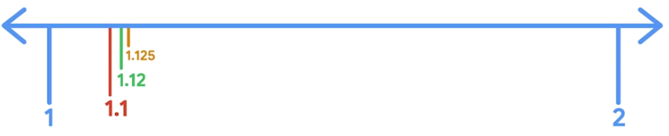

**<!!!>** DISCRETE vs. CONTINUOUS variables:

* COUNT the number of outcomes = discrete
* MEASURE the outcome = continuous
* Discrete or Continuous distributions:
* Discrete distributions represent discrete random variables
* continuous distributions represent continuous random variables
* sample space: the set of all possible values for a random variable
* sample space for single coin toss = {Head, Tails}
* sample space for single die roll= {1,2,3,4,5,6}

**The Binomial Distribution**

* The Binomial Distribution: a discrete distribution that models the probability of events with only 2 possible outcomes, success or failure.
* Assumes:
* Each event is **independent**
* The probability of success is the **same** for each event

(• Phân phối nhị thức: một phân phối **rời rạc** mô hình hóa xác suất của các sự kiện **chỉ có 2 kết quả** có thể xảy ra, **thành công hoặc thất bại.**

• Giả định:  
• Mỗi sự kiện là **độc lập**  
• Xác suất **thành công là như nhau** cho mỗi sự kiện)

* Mutually exclusive: 2 outcomes are mutually exclusive if they cannot occur at the same time
* Random experiment: a process whose outcome cannot be predicted with certainty
* Binomial experiment:
* The experiment consists of a number of repeated trials
* Each trial has only 2 possible outcomes
* The probability of success is the same for each trial
* Each trial is independent

(• Thí nghiệm bao gồm một **số lần thử lặp lại**  
• Mỗi lần thử chỉ có **2 kết quả** có thể xảy ra  
• **Xác suất thành công là như nhau** cho mỗi lần thử  
• Mỗi lần thử là **độc lập**)

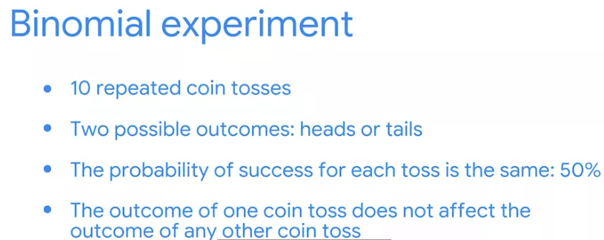

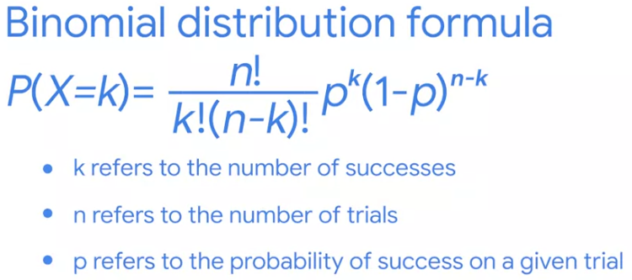

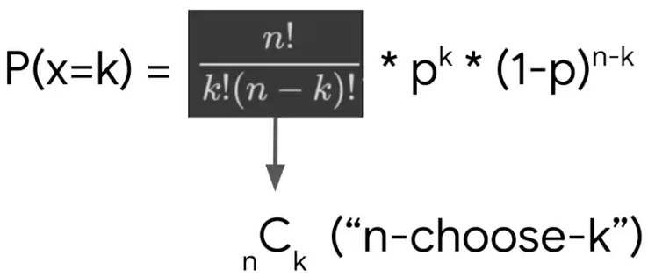

--------------------------------------------------------------------------------------------

The Poisson distribution:

* Poisson distribution: models the probability that a certain number of events will occur **during a specific time period.**

(Phân phối Poisson: mô hình hóa xác suất một số lượng sự kiện nhất định sẽ xảy ra **trong một khoảng thời gian cụ thể**.)

* Used to:
* Calls per hour for a customer service call center
* Visitors per hour for a website
* customer per day at a restaurant
* Severe storms per month in a city
* Poisson experiment:
* The number of events in the experiment can be counted
* The mean number of events that occur during a specific time period is known
* Each event is independent

(• Số lượng sự kiện trong thí nghiệm **có thể được đếm được**  
• Số trung bình các sự kiện xảy ra trong **một khoảng thời gian cụ thể** là đã biết  
• Mỗi sự kiện là **độc lập**)

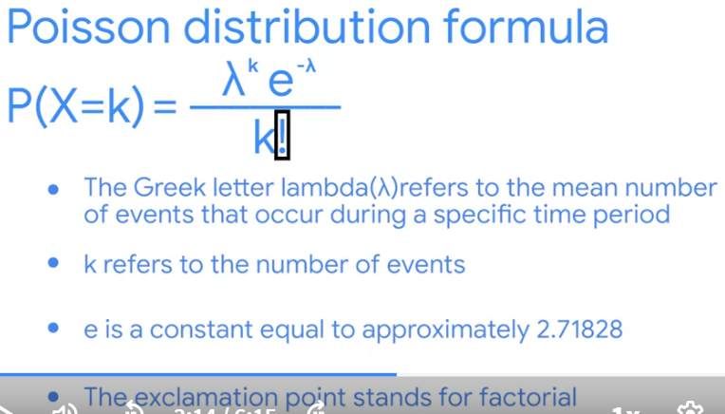

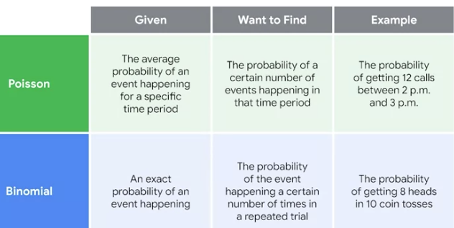

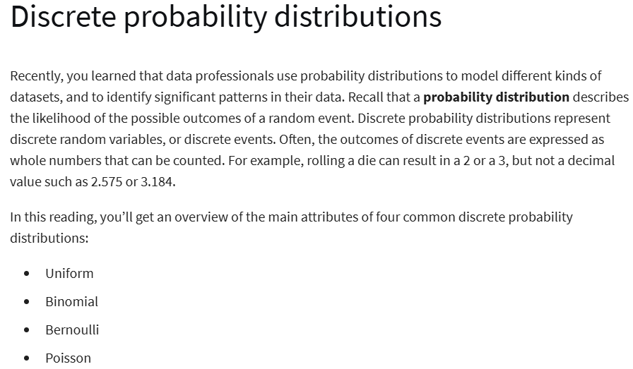

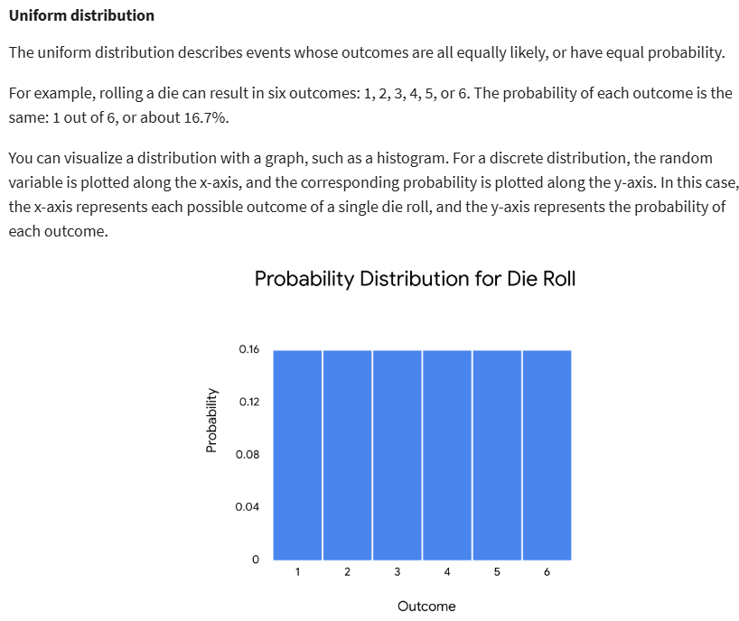

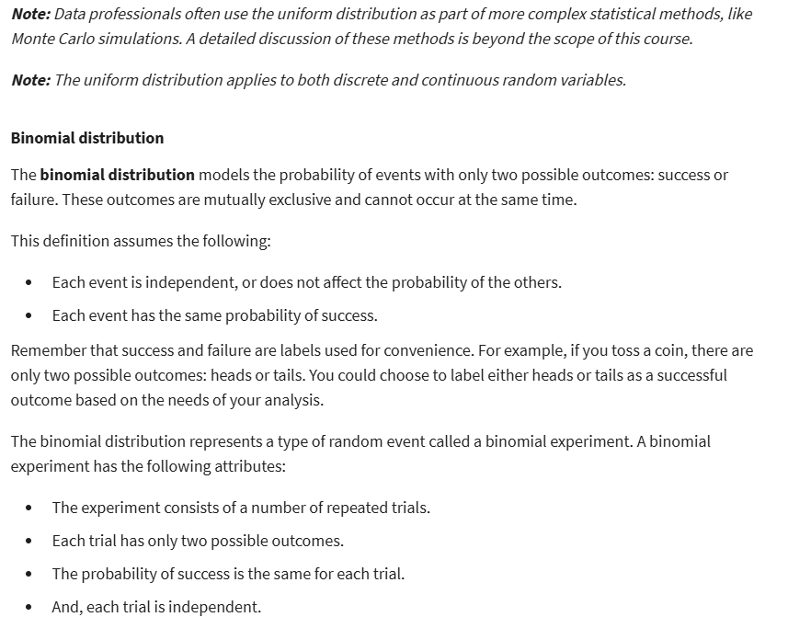

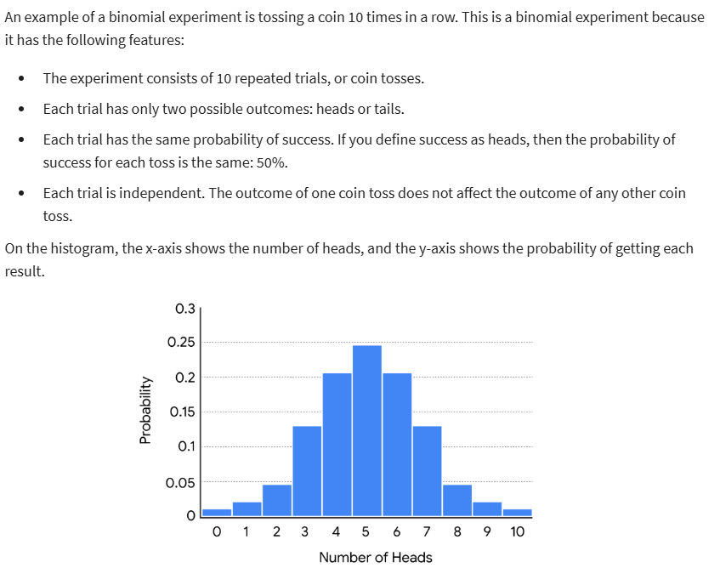



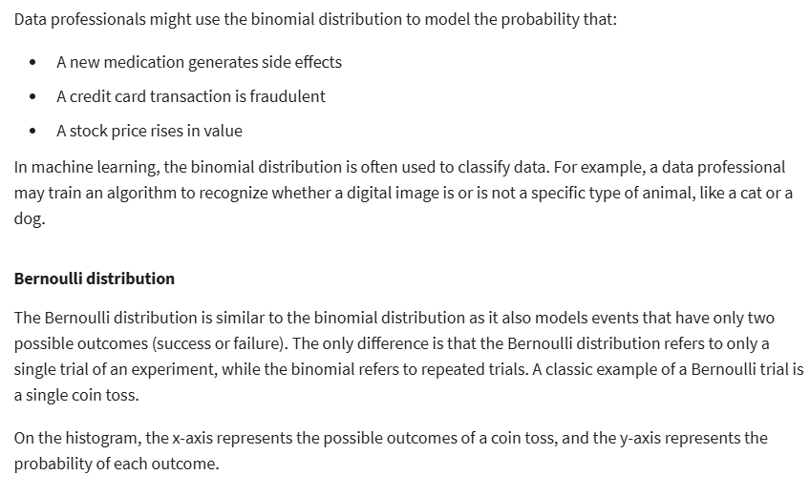



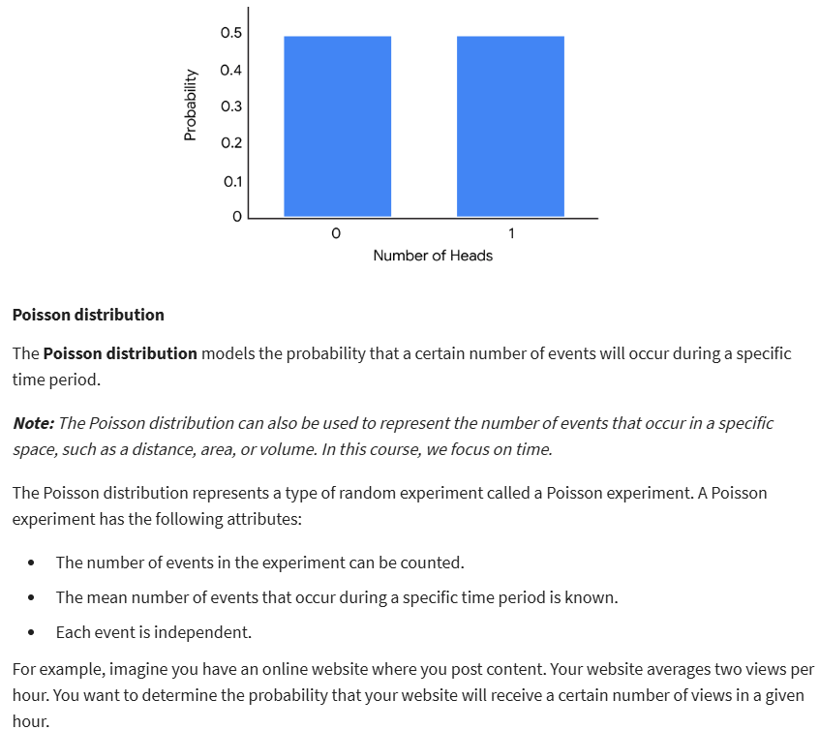



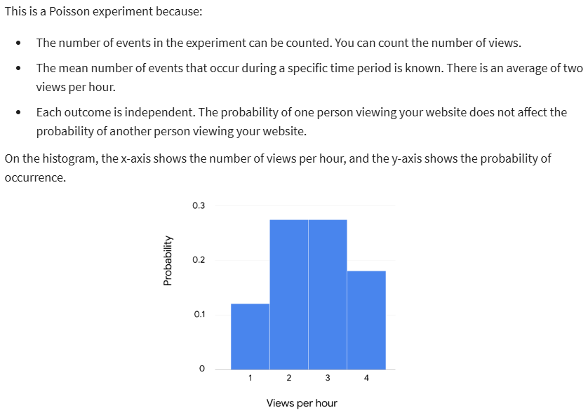

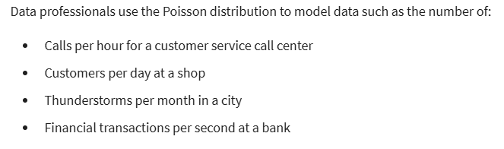

**The Normal Distribution: (Gaussian Distribution)**

* Normal distribution: a continuous probability distribution that is symmetrical on both sides of the mean and bell-shaped
* Height, weight, blood pressure, IQ, salaries
* The shape is a bell curve
* The mean is located at the center of the curve
* The curve is symmetrical on both sides of the center
* The total area under the curve equals 1
* The empirical rule:
* 68% of values fall within 1 standard deviation of the mean
* 95% // 2 //
* 97% // 3 //

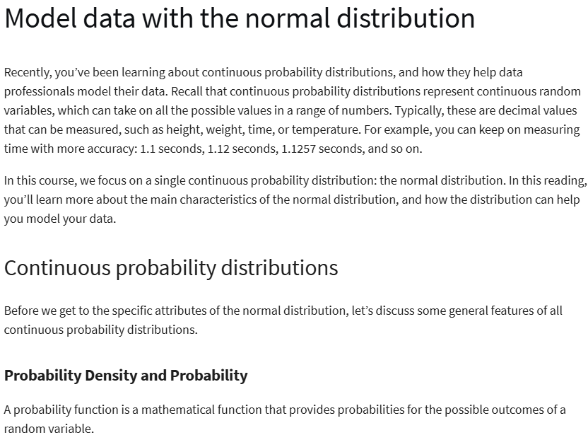

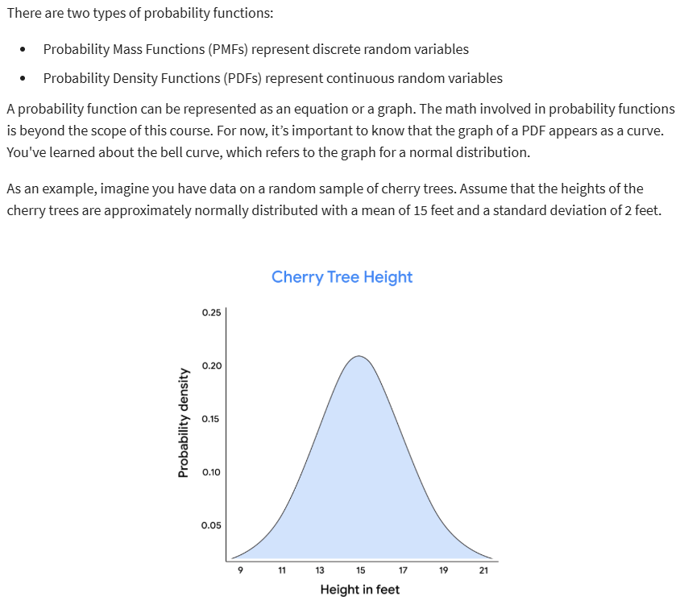

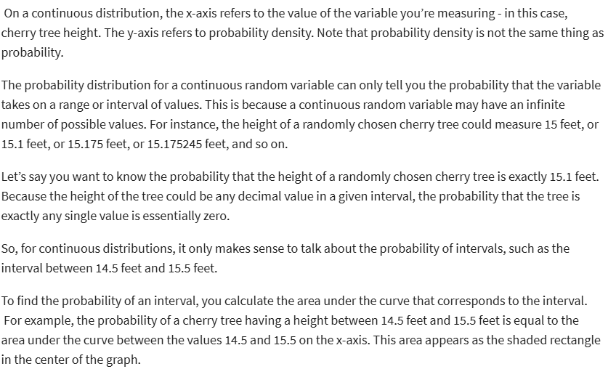

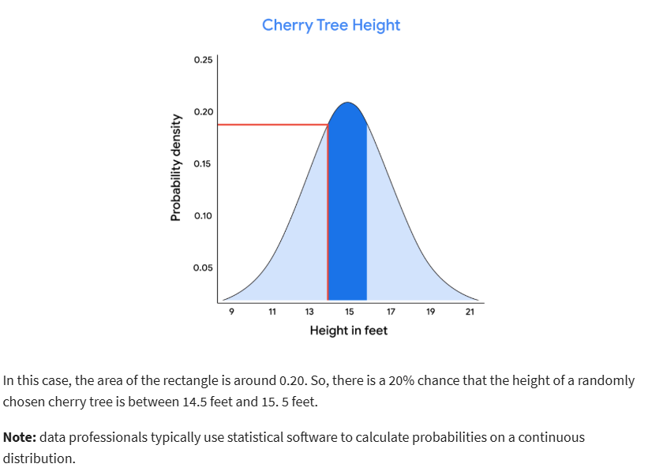

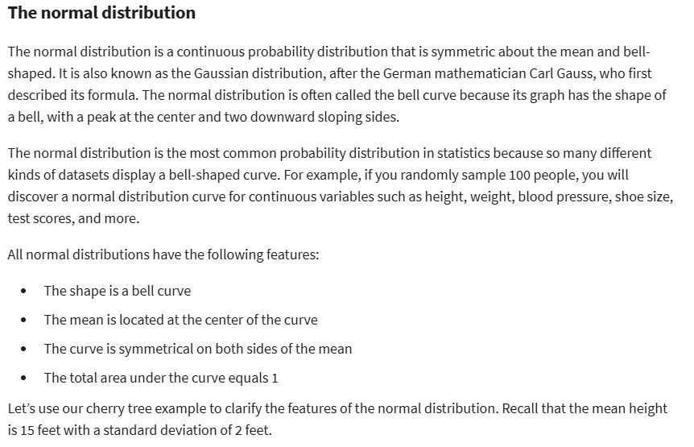



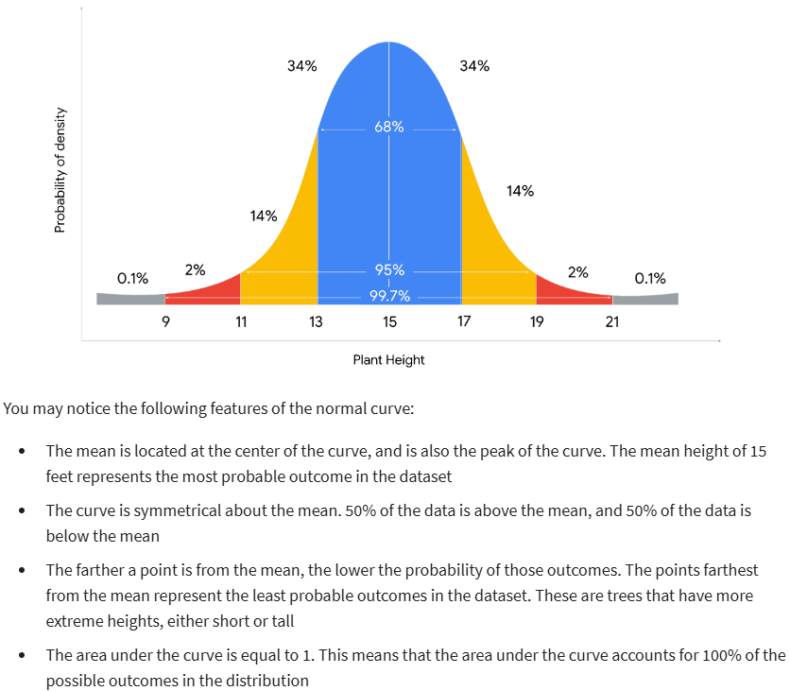

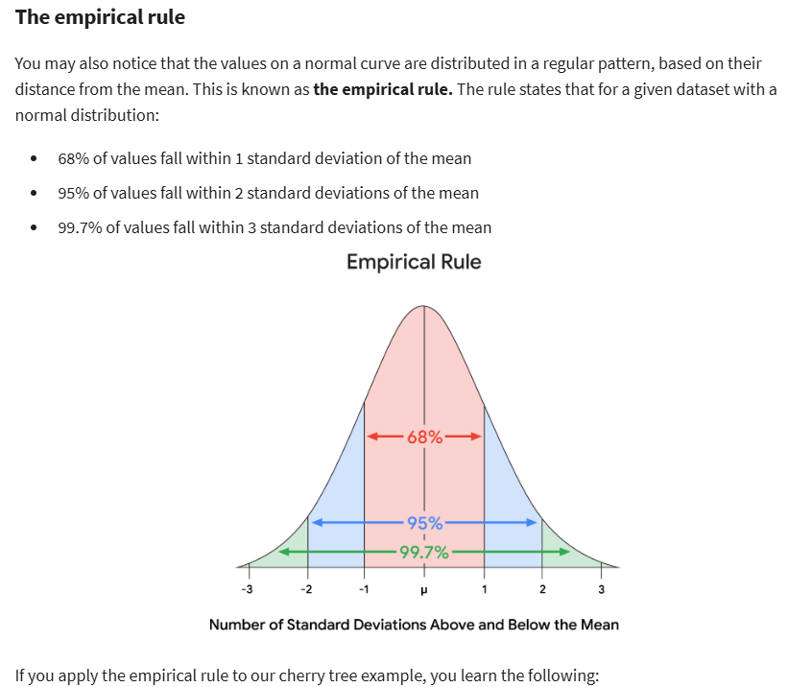



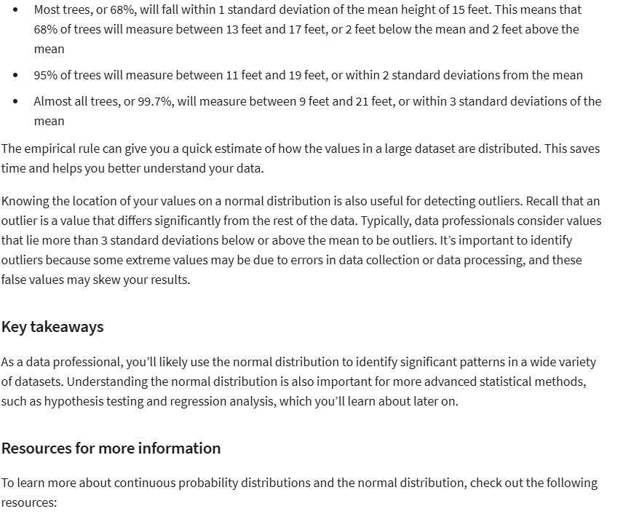

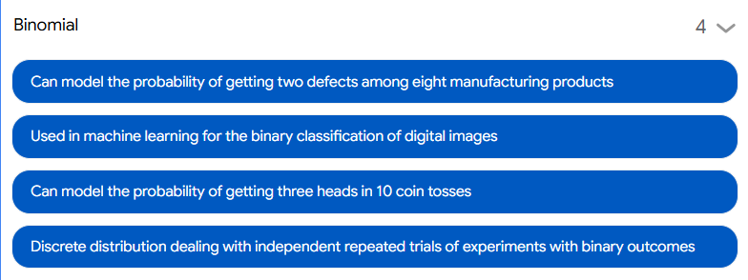

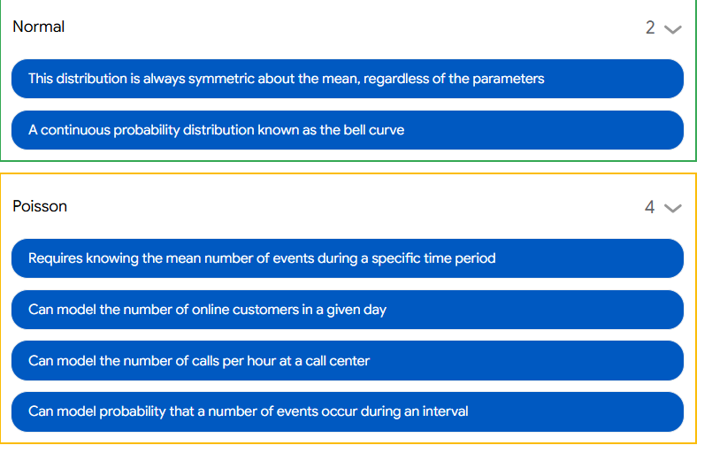

**Standardize data using z-scores**

* Z-score: a measure of **how many standard deviations** below or above the population mean a data point is
* Means how far from the mean a data point is
* Z-score is 0 if the value is equal to the mean
* Z-score is positive if the value is greater than the mean
* Z-score is negative if the value is less than the mean
* Standardization: the process of putting different variables on the same scale
* Anomaly detection application:
* Fraud in financial transactions
* Flaws in manufacturing products
* Intrusions in computer networks

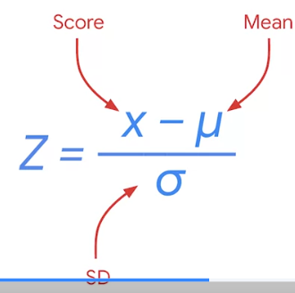

**Work with probability distributions in Python**

* Python for Stats:
* SciPy stats: open-sourced, for solving maths, scientific, engineering, tech problems. Allows to manipulate and visualize
* Statsmodels: designed specifically for Stats

WEEK 3:

**Intro to Sampling:**

* Sampling: the process of drawing a subset of data from a population
* How many products in an app store do we need to test to feel confident that all the products are secure from malware?
* How do we select a sample of users to run an effective A/B test for an online retail store?
* How do we select a sample of customers of a video streaming service to get reliable feedback on the shows they watch?

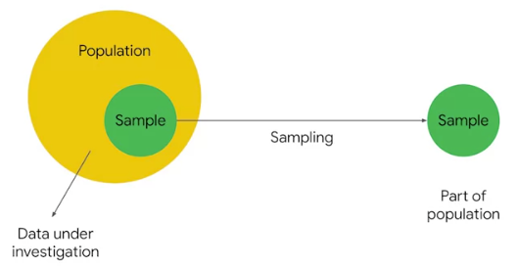

* Sampling is beneficial because:
* Requires less time
* Saves money and resources
* More practical than analyzing an entire population
* Representative sample: accurately reflects the characteristics of a population

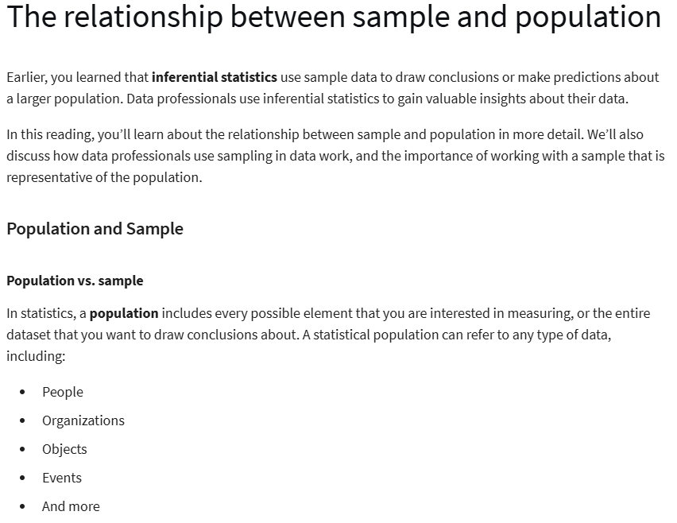



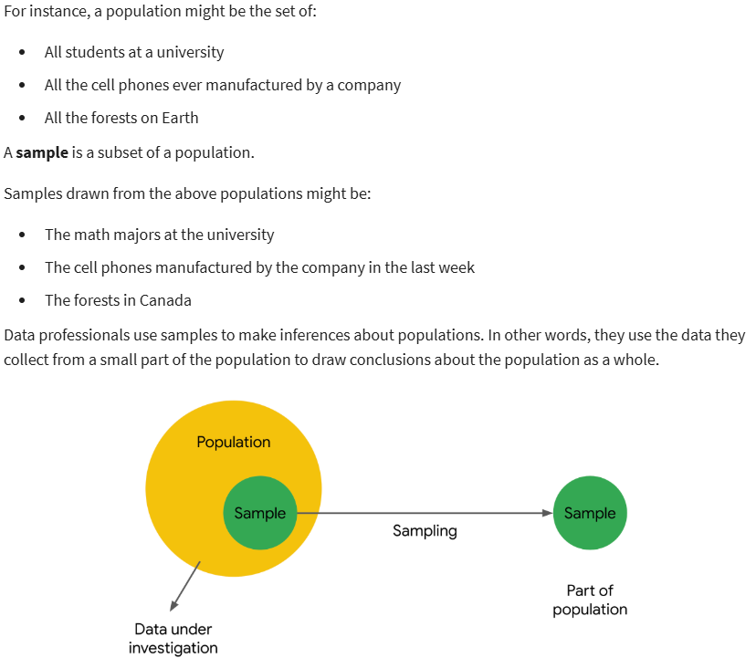

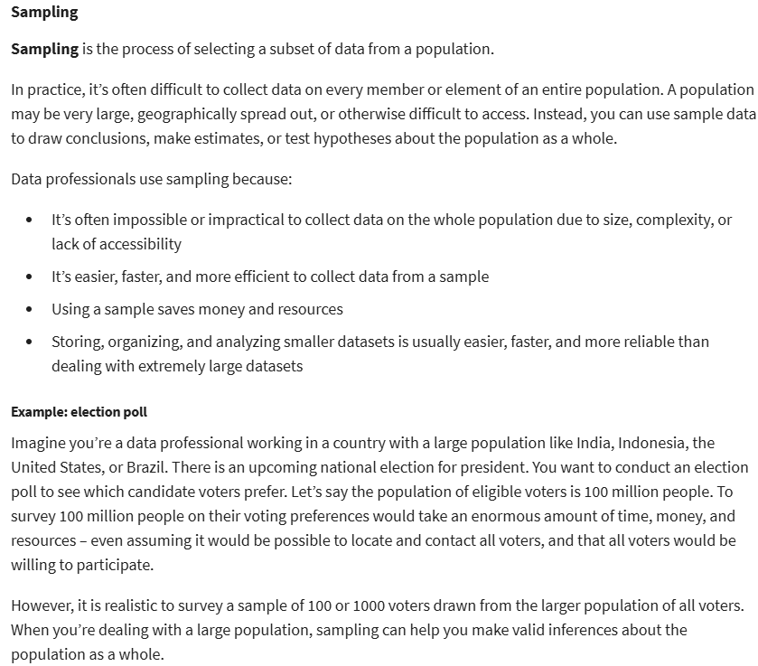

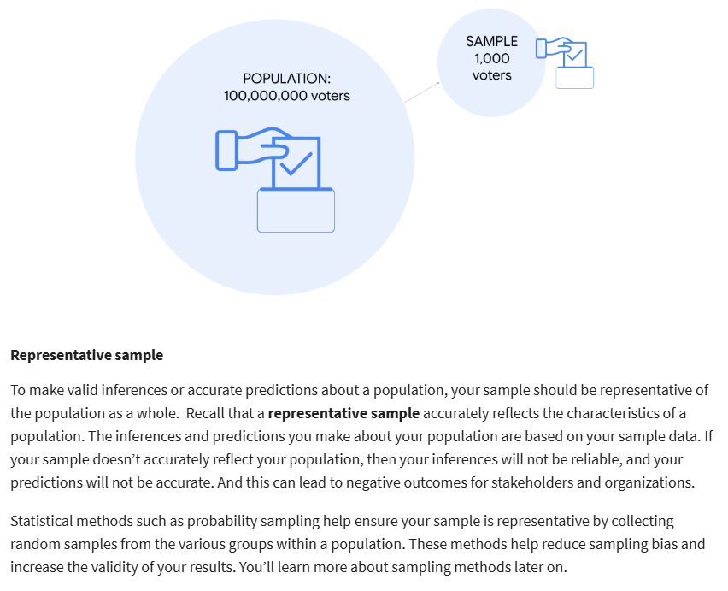

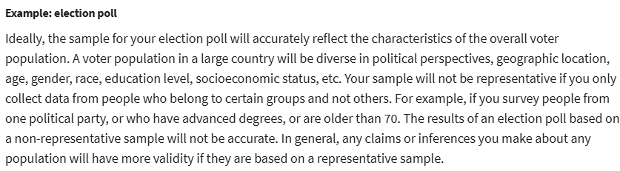



**The sampling process**

* Step 1: identify the **target population**
* Step 2: select the **sampling frame**
* Step 3: choose the **sampling method**
* Step 4: determine the **sample size**
* Step 5: collect the sample **data**
* Target population: the complete set of elements that you’re interested in knowing more about
* Sampling frame: a list of all items in your target population

<!!!> Target population vs. Sampling frame:

* Target population is **general**
* Sampling frame is **specific**
* Sampling methods:
* Probability sampling: uses **random** selection to generate a sample
* Non-probability sampling: based on convenience or personal preference
* Sample size: the number of individuals or items chosen for a study or experiment

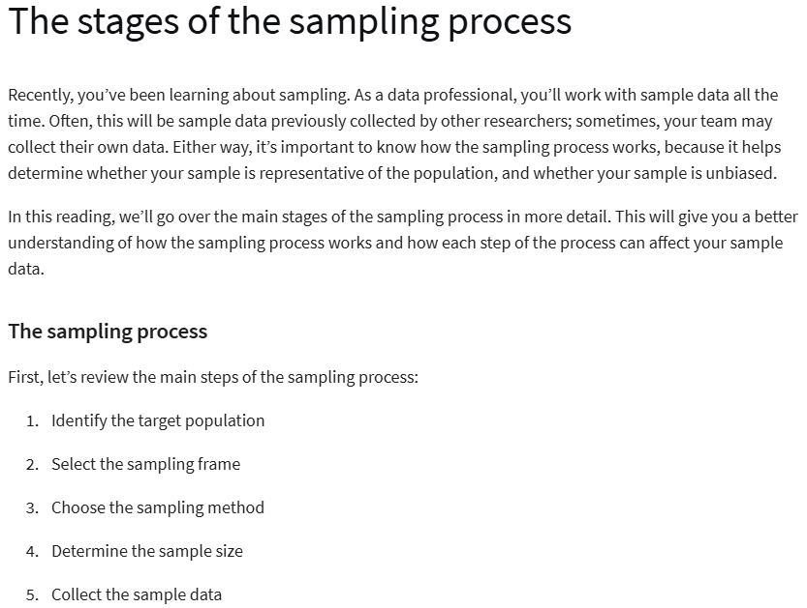

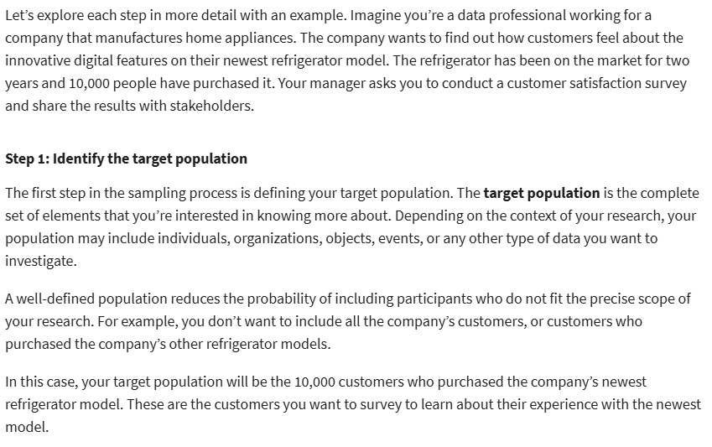

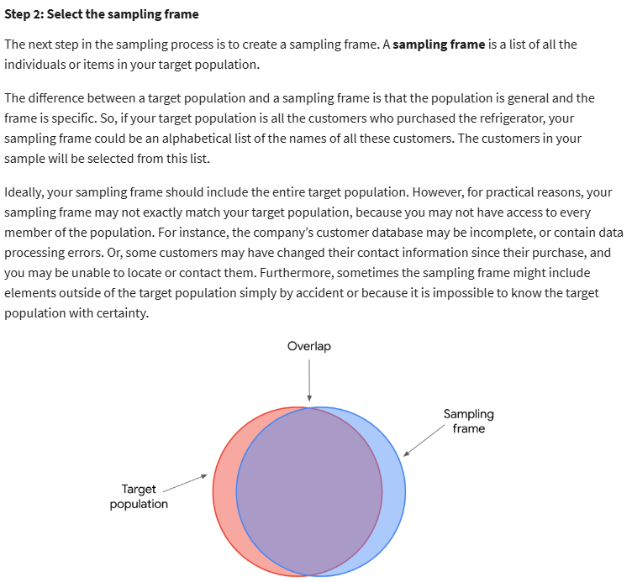

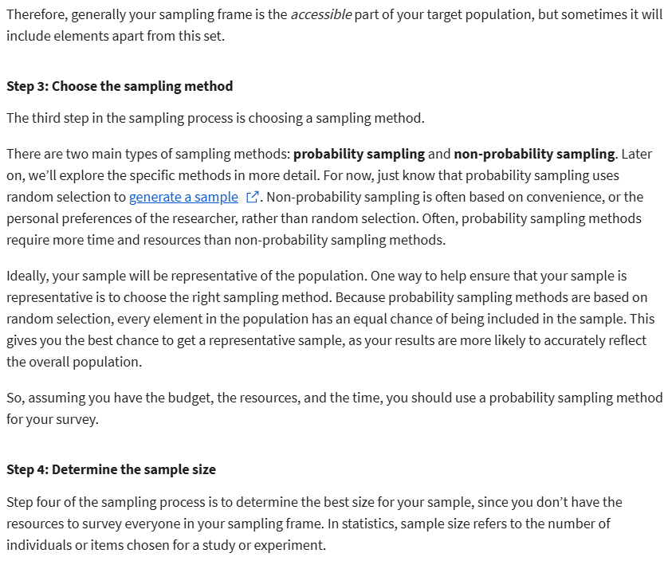

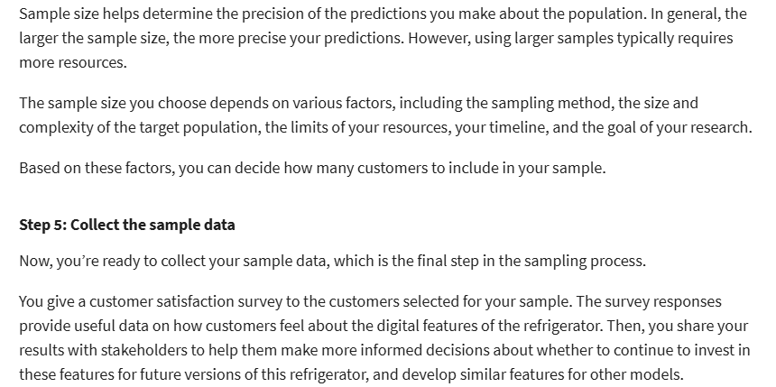

**Compare sampling methods**

* 4 methods:
* Simple random sampling
* Stratified random sampling (**phân tầng)**
* Cluster random sampling
* Systematic random sampling (**có hệ thống)**
* Simple random sample: every member of a population is selected randomly and has an equal chance of being chosen
* Fairly representative
* Avoid bias

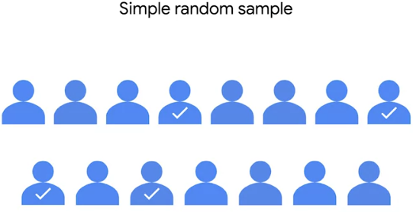

* Stratified random sample: divide a population into groups and randomly select some members from each group to be in the sample
* Members from each group are included
* However, difficult to identify appropriate strata for a study if you lack knowledge of a population

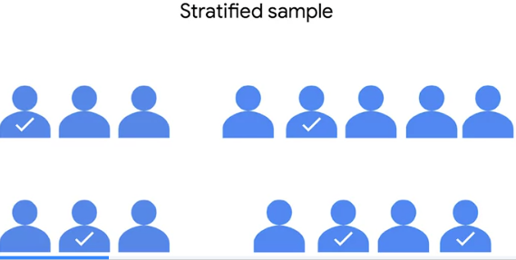

* Cluster random sample: divide a population into clusters, randomly select certain clusters, and include all members from the chosen clusters in the sample
* Helpful when dealing with large and diverse populations that have clearly defined subgroups
* However, difficult to create clusters that accurately reflect the overall population

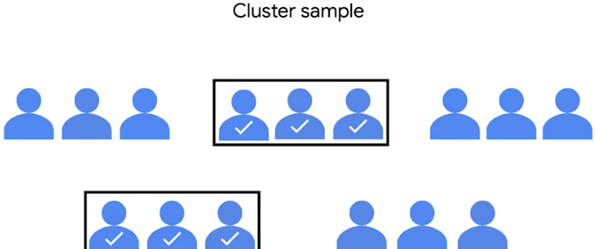

* Systematic random sample: put every member of a population into an ordered sequence. Then, you choose a random starting point in the sequence and select members for your sample **at regular intervals.**
* Representative
* Quick and convenient
* However, need to know the size of the population

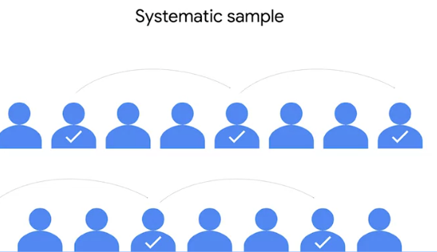

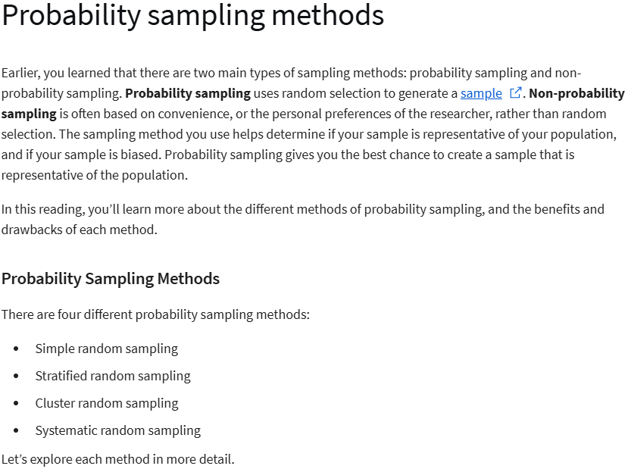

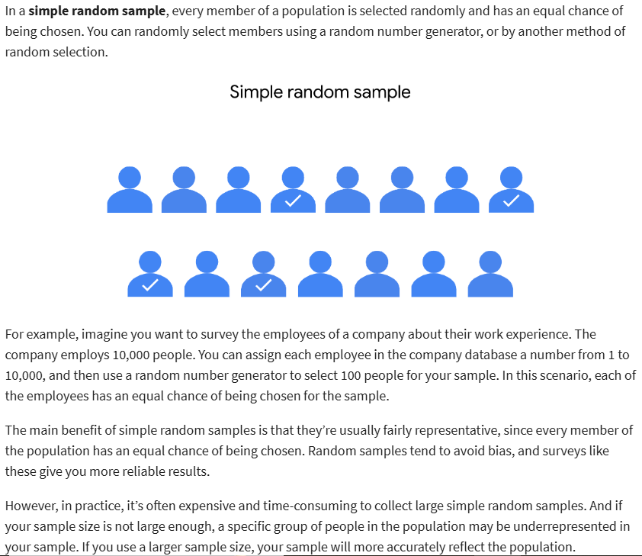

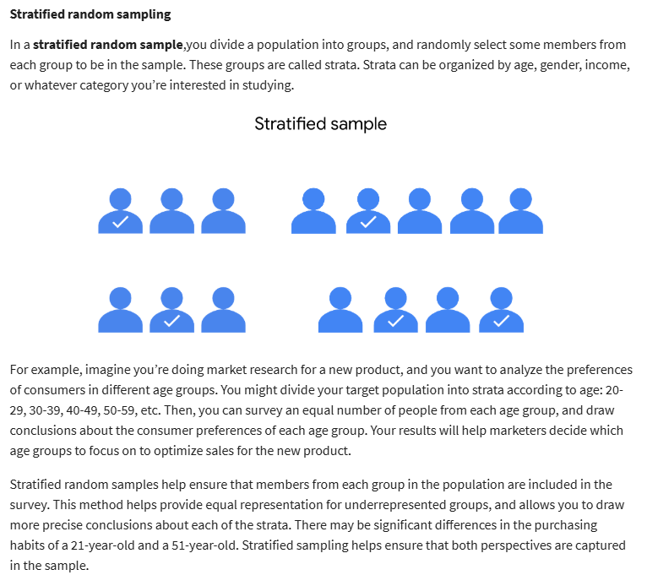

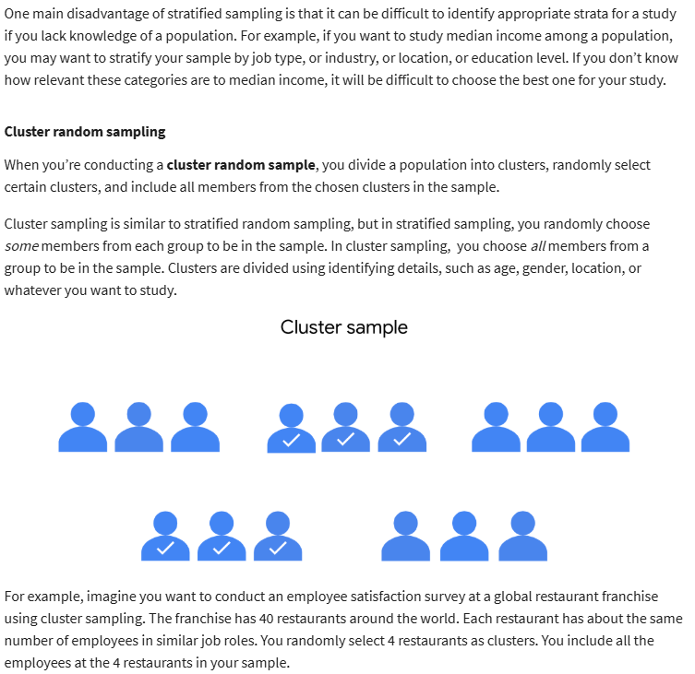

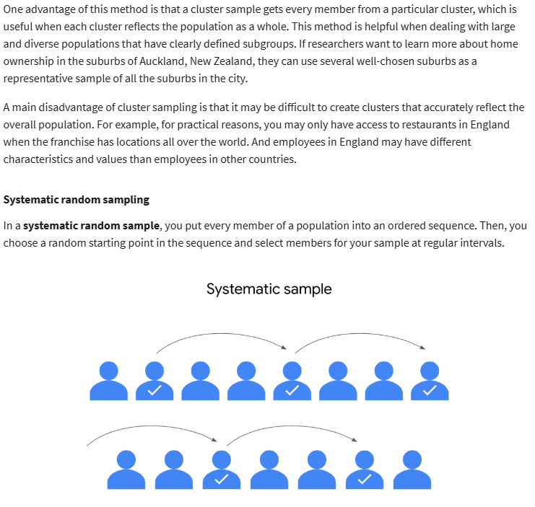

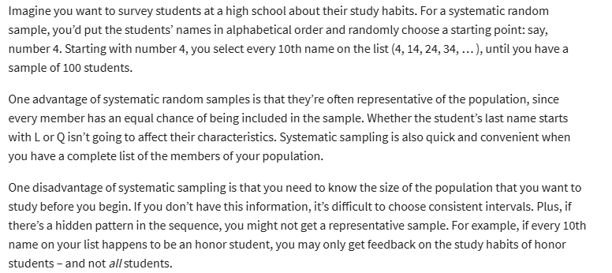

**The impact of bias in sampling**

* Sampling bias: when a sample is **not representative** of the population as a whole
* Non-probability sampling is often less expensive and more convenient for researchers to conduct
* 4 methods:
* Convenience sampling
* Voluntary response sampling
* Snowball sampling
* Purposive sampling
* Convenience sampling: choose member of a population that are easy to contact or reach
* Undercoverage bias: when some members of a population are inadequately represented in the sample
* Voluntary response sample: consists of members of a population who volunteer to participate in a study
* Nonresponse bias: when certain groups of people are less likely to provide responses
* Snowball sampling: researchers recruit initial participants to be in a study and then ask them to recruit other people to participate in the study
* Leading to sample bias
* Purposive sample: researchers select participants based on the purpose of their study
* Lead to sample bias

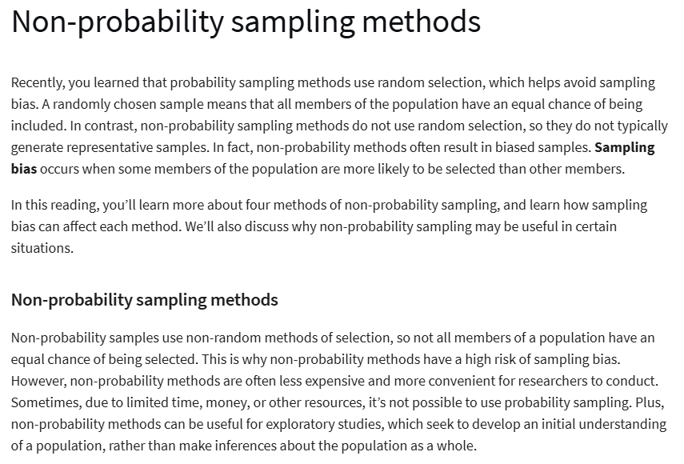

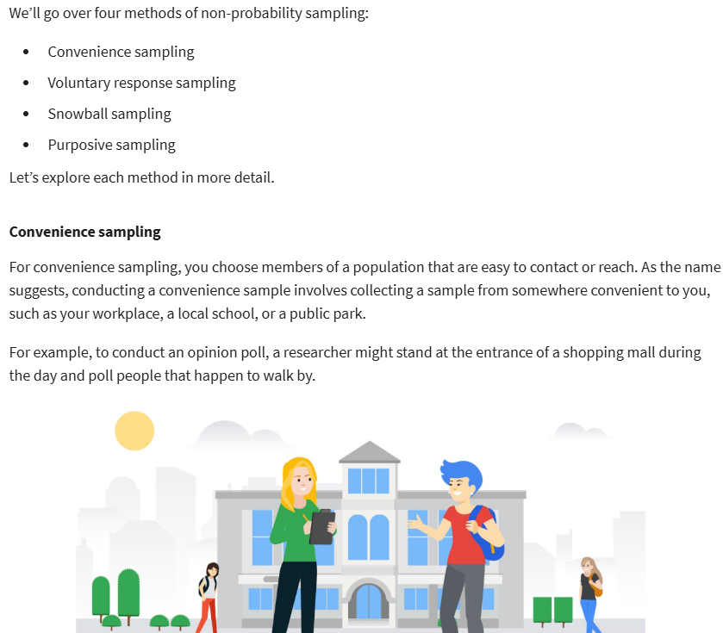

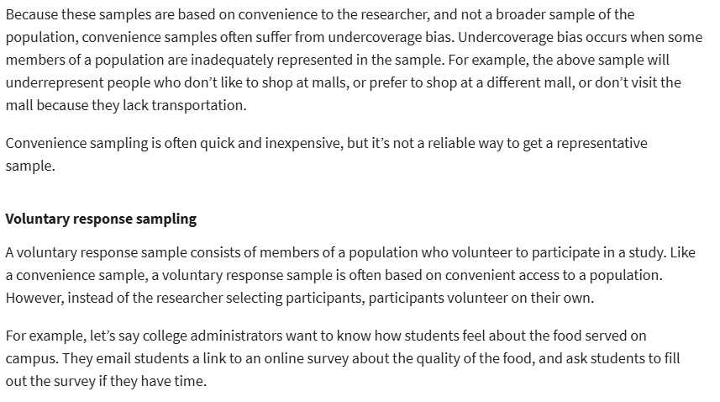

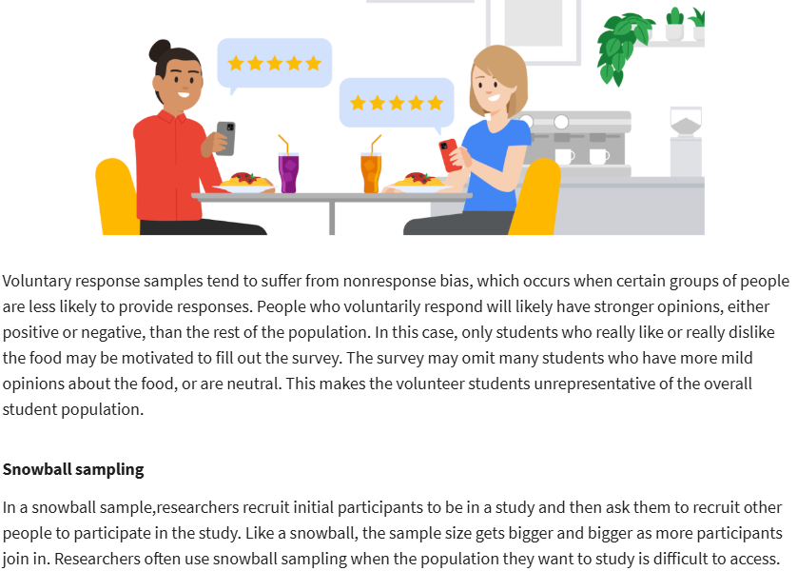

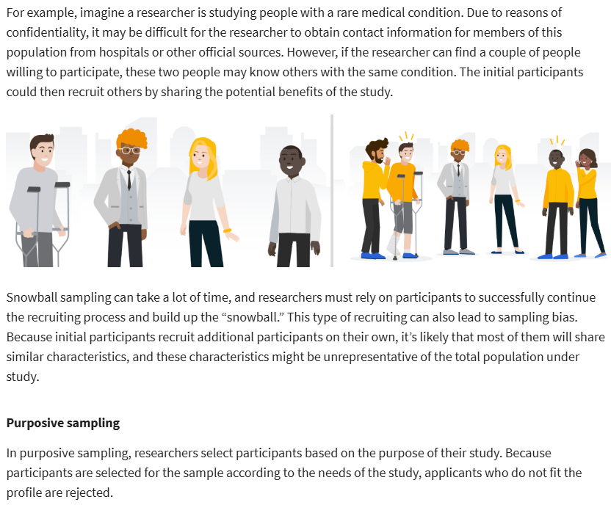

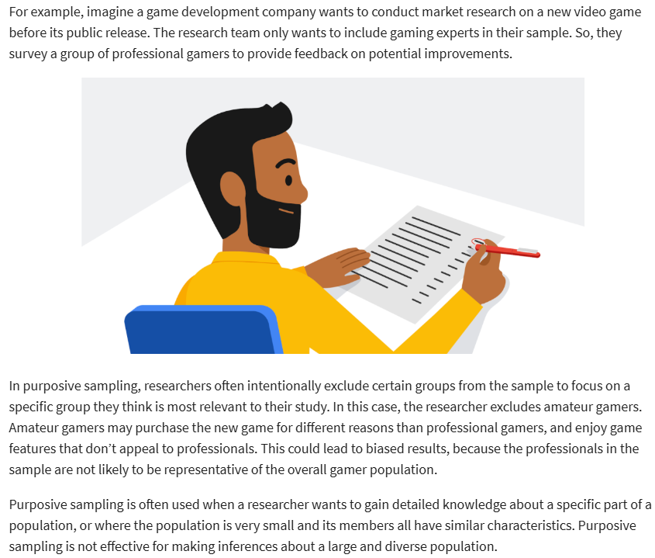

**How sampling affects your data**

* Point estimate: use a **single** value to estimate a population parameter
* Sampling distribution: a probability distribution of a sample stats
* Sampling variability: **how much** an estimate varies between samples
* Standard error:
* *Larger std error = Sample means are more spread out*
* *Smaller std error = Sample means are closer together*

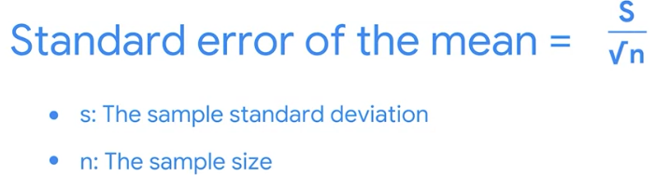

**<!!!>** as sample size gets larger, std error gets smaller

This is because the mean of your sampling distribution gets closer to the population mean.

**The central limit theorem**

* Used to:
* The mean annual household income for an entire city or country
* The mean height and weight for an entire animal or plant population
* The mean commute time for all the employees of a large corporation
* Central limit theorem: the sampling distribution of the mean approaches a normal distribution as the sample size increases

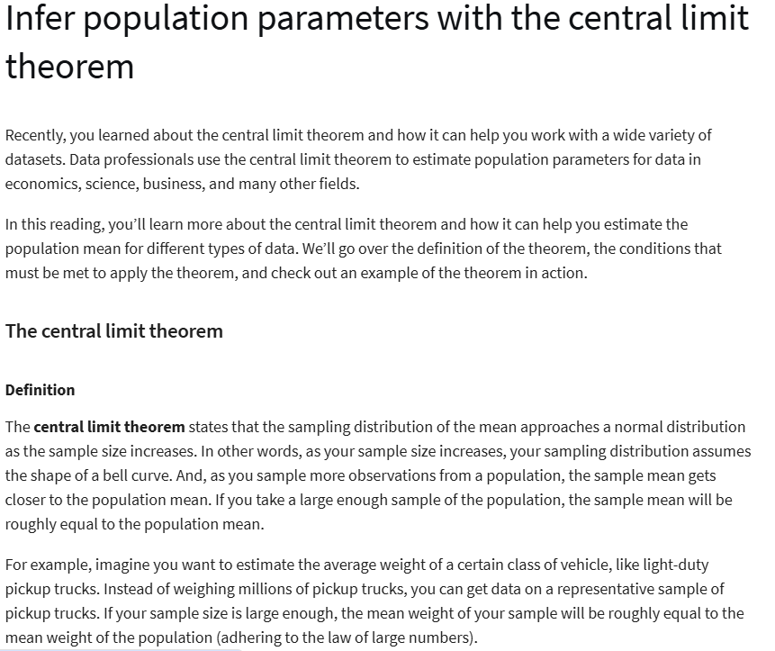

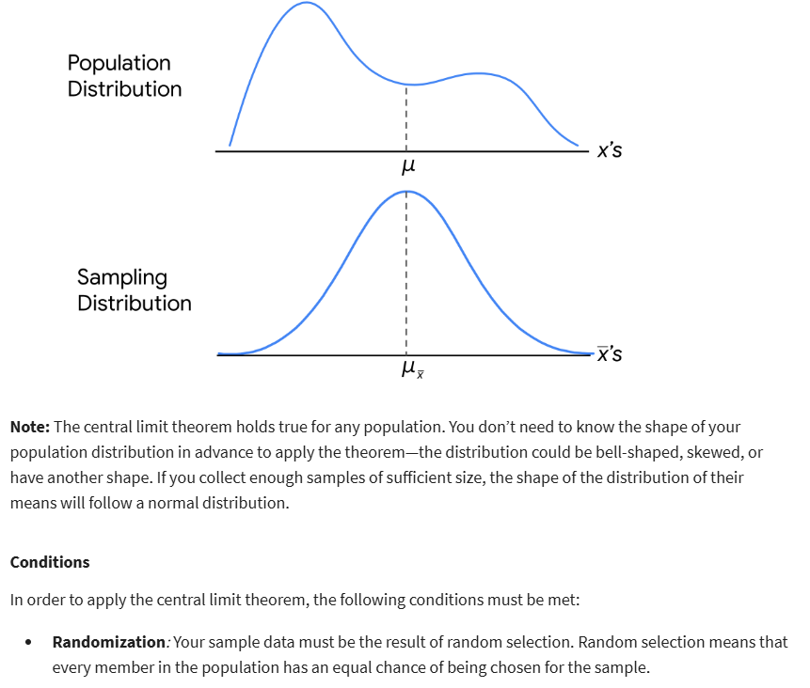

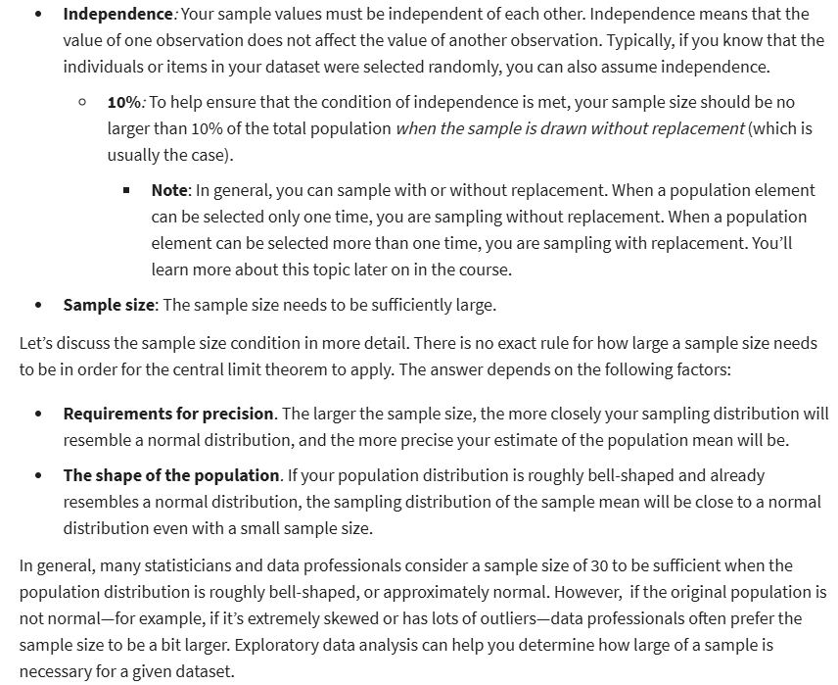



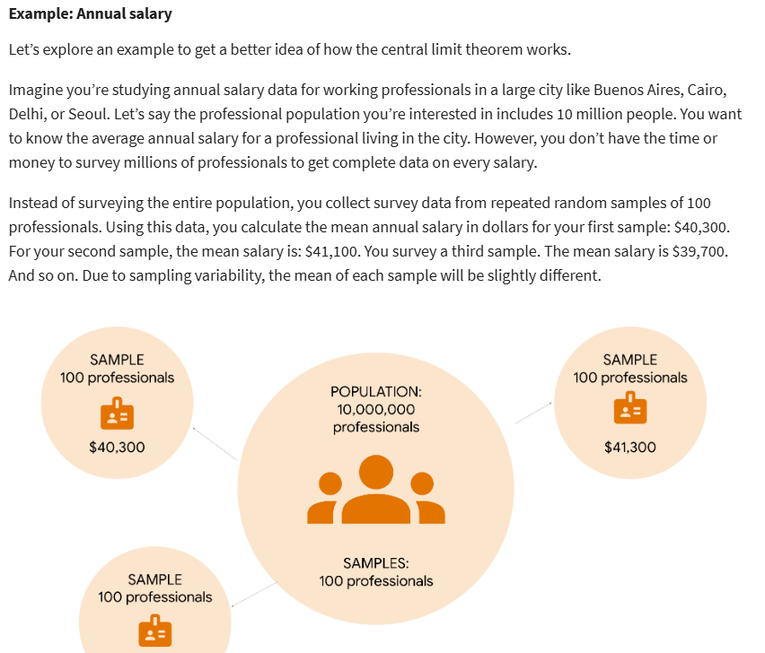

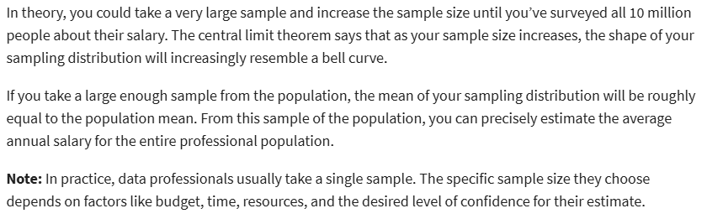

**The sampling distribution of the proportion**

* Population proportion: the percentage of individuals or elements in a population that share a certain characteristic

(**Tỷ lệ dân số**: phần trăm số cá nhân hoặc phần tử trong một dân số **có cùng một đặc điểm nhất định**.)

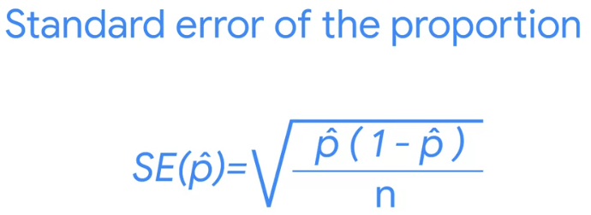

* The more accurate the estimate, the smaller the std error

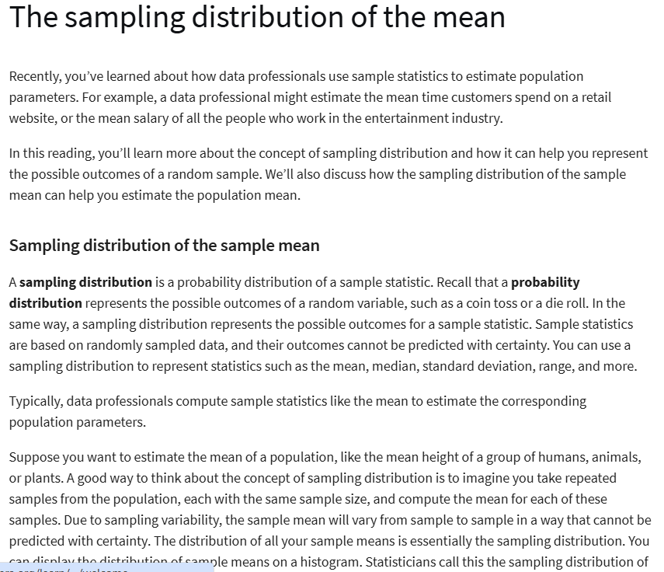

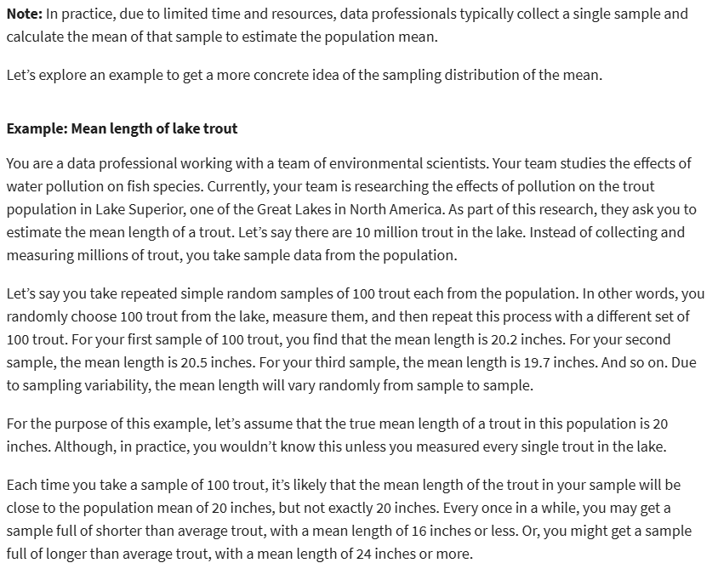

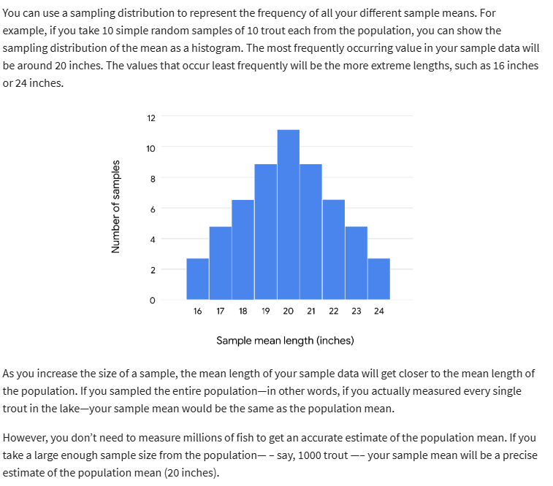

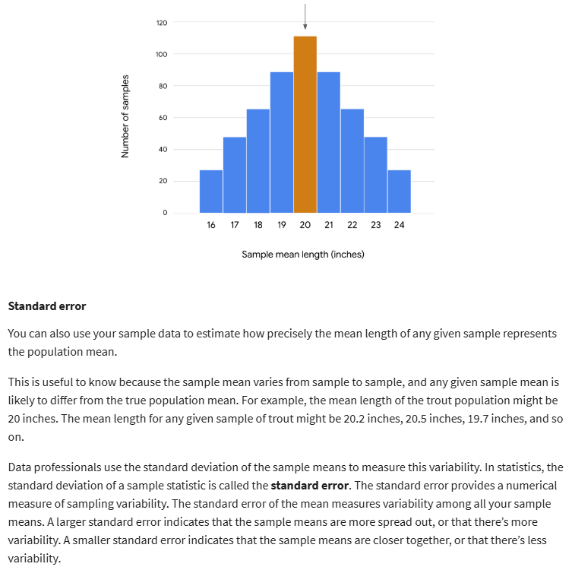



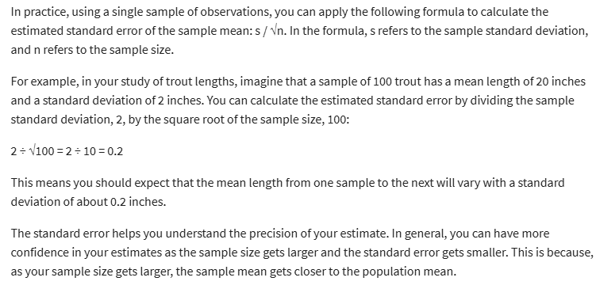

**Sampling distributions with Python**

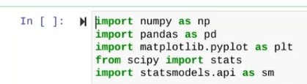

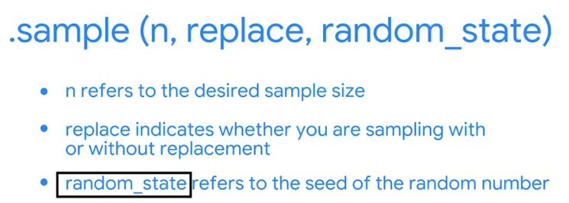

* Sampling w replacement: when a population element can be selected MORE than one time (replace=TRUE)
* Sampling w/o replacement: when a population element can be selected ONLY one time
* Random seed: a starting point for generating random numbers

**WEEK 4:**

**Introduction to Confidence intervals**

* Point estimate: uses a single value to estimate a population parameter
* Interval estimate: uses a range of values to estimate a population parameter
* Confidence interval:
* Sample stats
* Margin of error
* Confidence level
* Interval: sample stats +/- margin of error
* Margin of error: the max expected difference between a population parameter and a sample estimate.

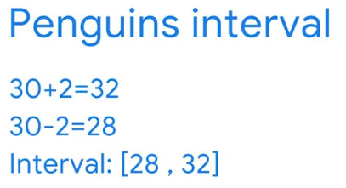



* Confidence level: describes the likelihood that a particular sampling method will produce a confidence interval that includes the population parameter.
* Expresses the uncertainty of the estimation process
* Common confidence levels: 90%, 95% (popular choice), 99%

**Interpret confidence intervals**

* You can expect that:
* **95%** of intervals capture the population mean
* **5%** of intervals **DO NOT** capture the population mean

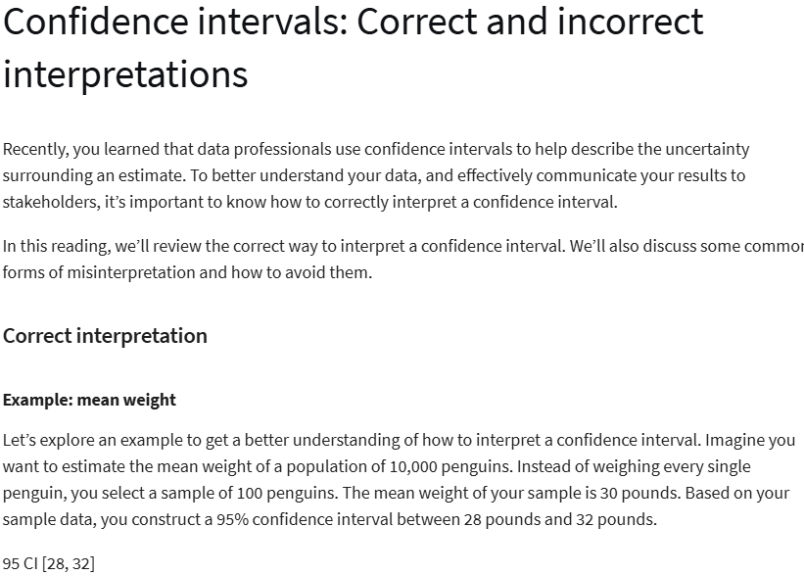

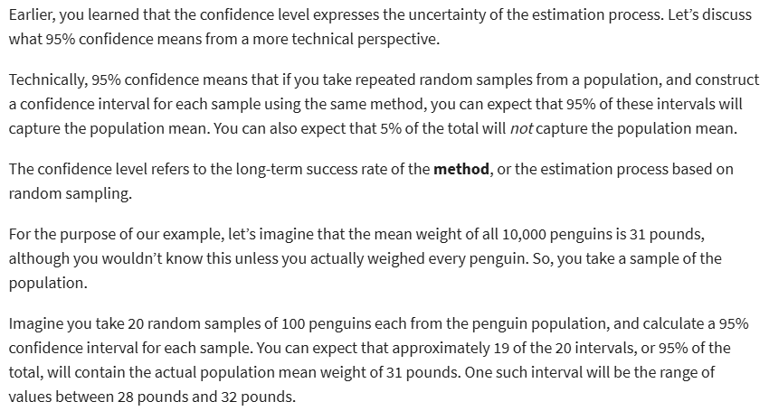

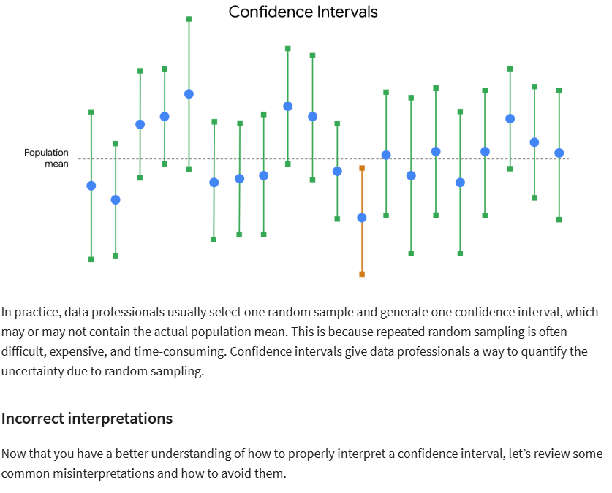

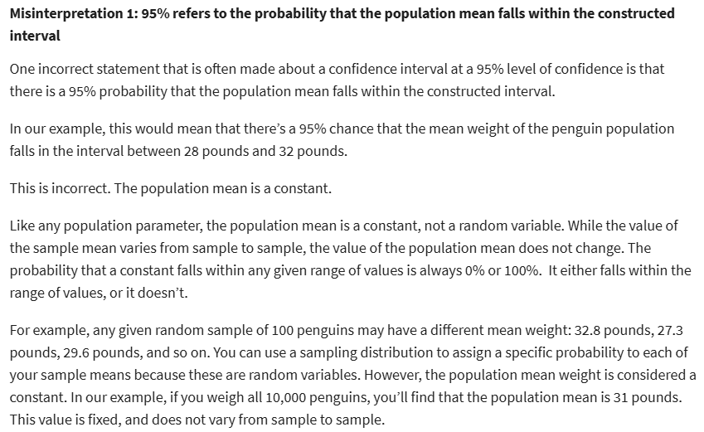

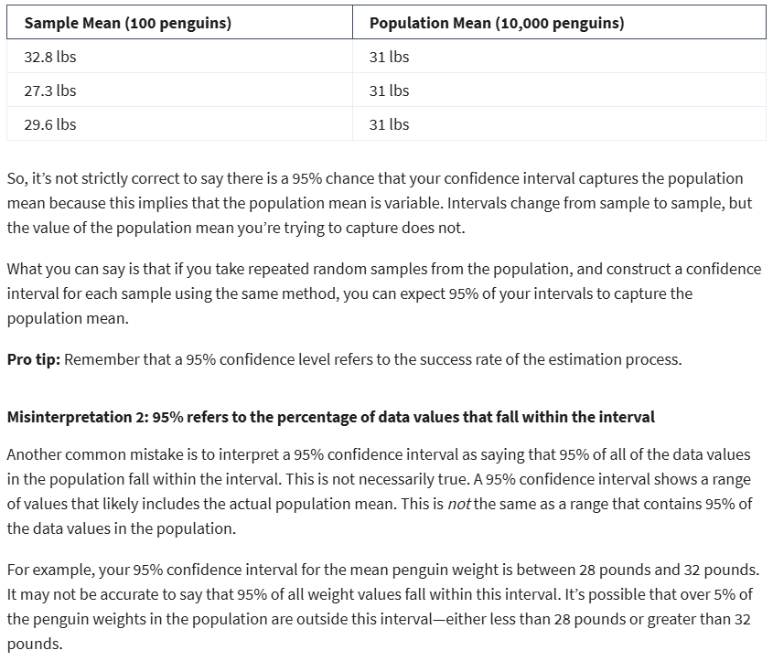

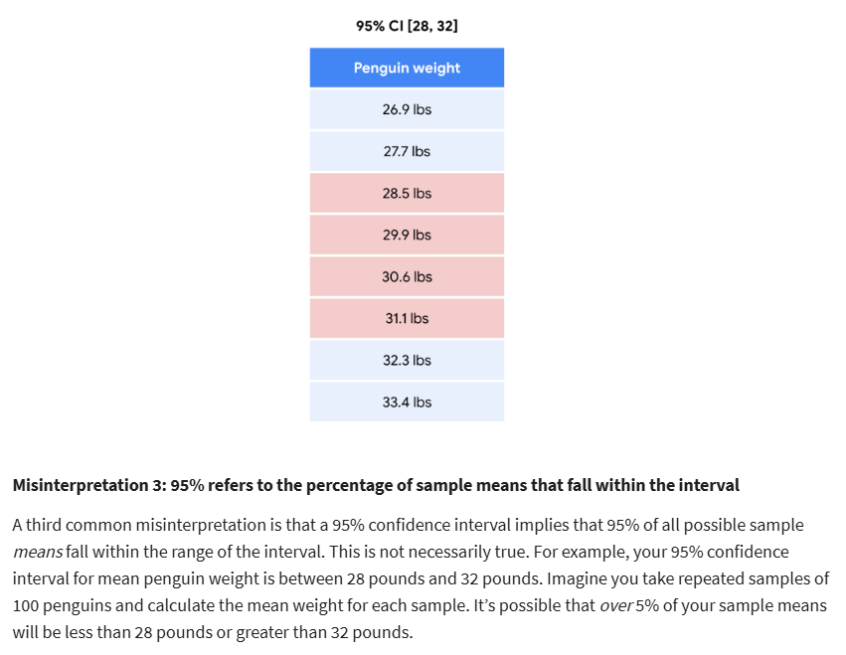

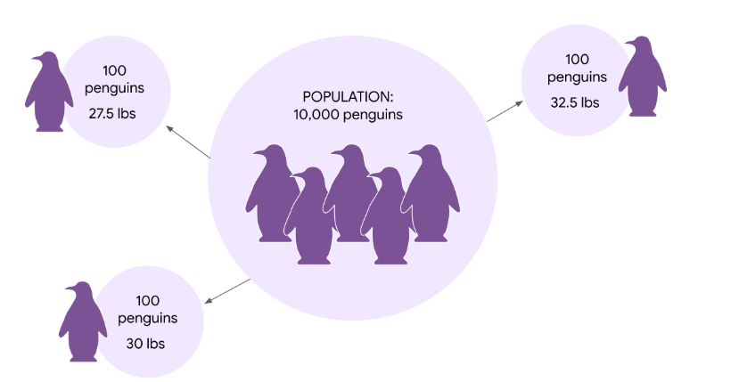

**Construct a confidence interval for a proportion**

* Steps:
* Identify a sample stats: **proportion**
* Choose a confidence level: **95%**
* Find the margin of error:

The range of values above and below the sample stats

= 1.96 * 0.05 = 0.098

* Calc the interval: **95% CI [45.2, 64.8]**

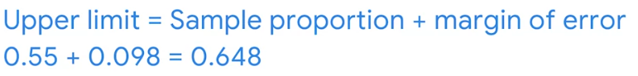

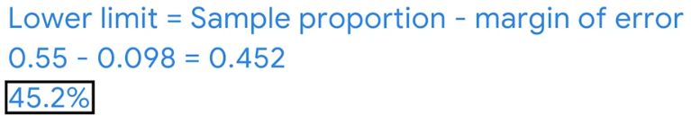

**Construct a confidence interval for a mean**

* Steps:
* Identify a sample stats: **mean**
* Confidence level: **95%**
* Margin of error: z-score* SE(std error) = 1.96*0.15 = **0.294**

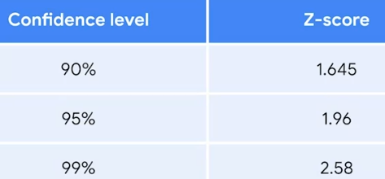

* Calc the interval: **[20:12, 20:48]**

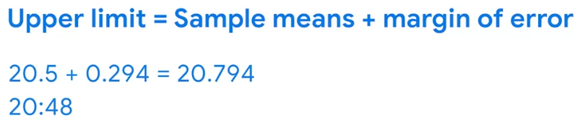

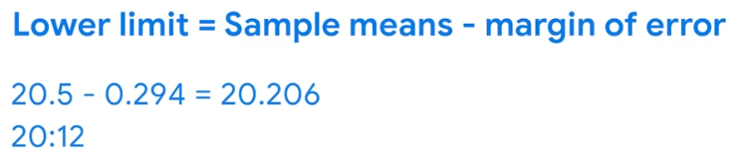

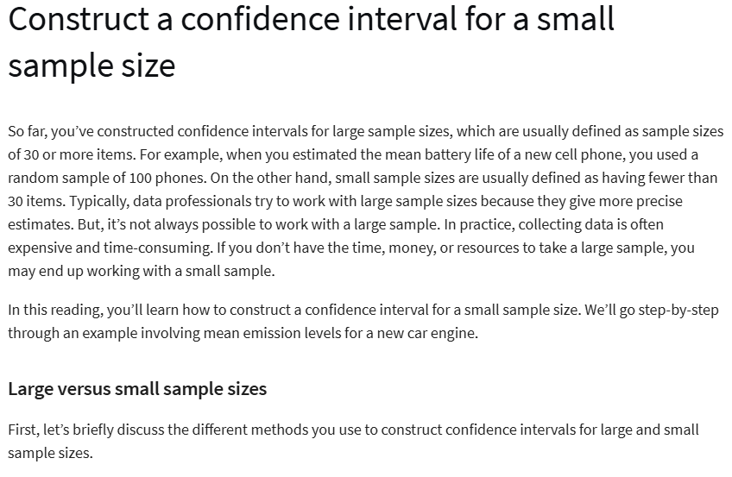

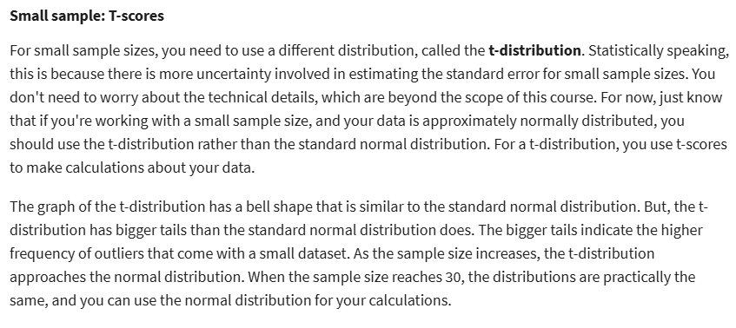

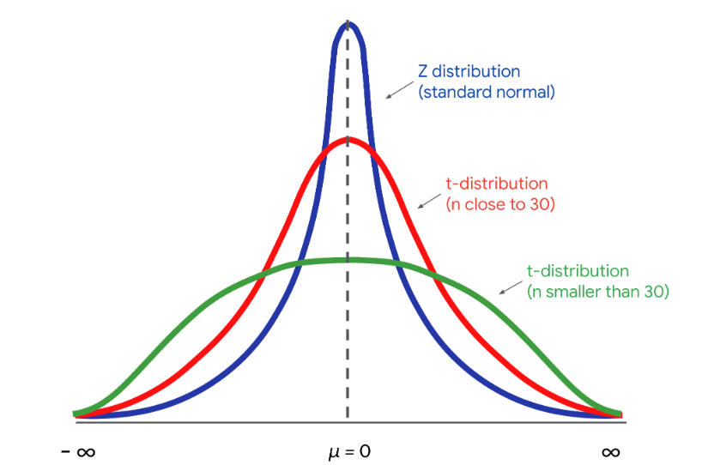

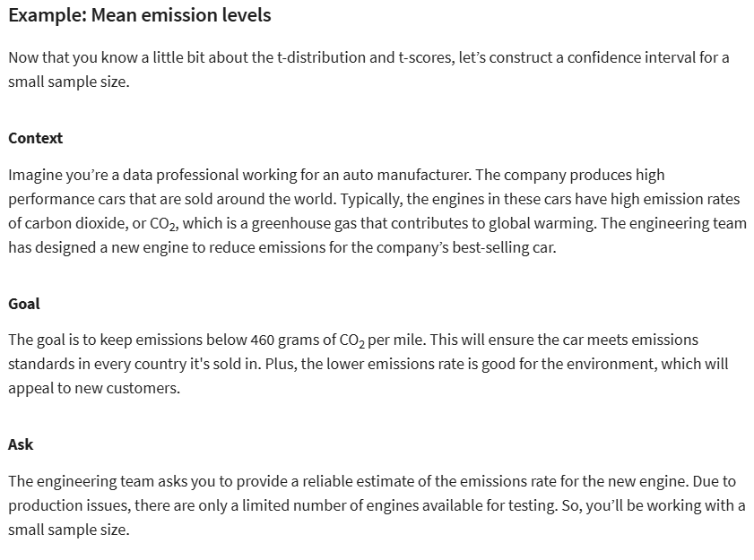

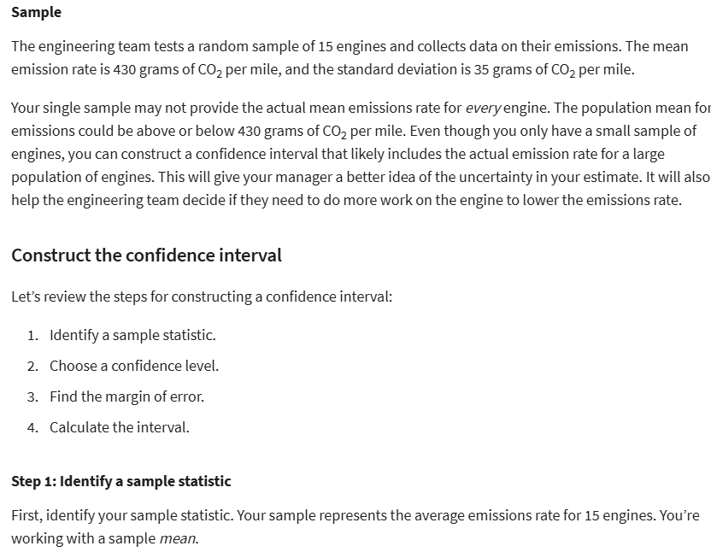

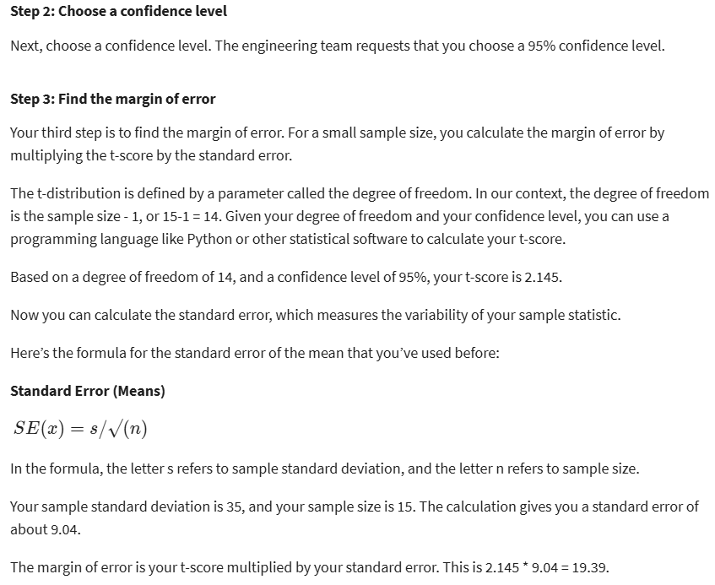

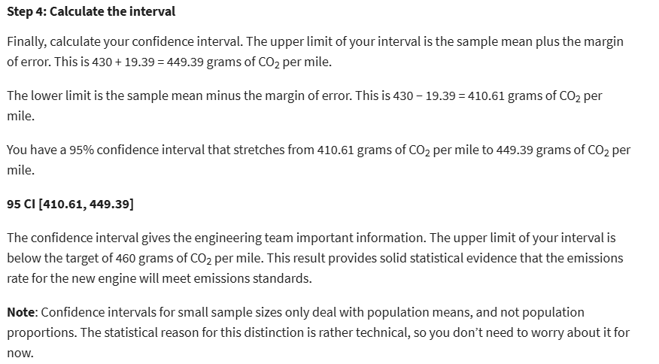

**Confidence intervals with Python**



* **Alpha**: Confidence level, 95%
* **Loc**: sample mean
* **Scale**: sample standard error

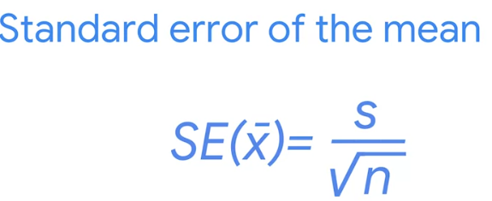

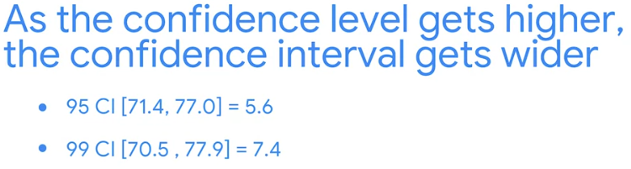

**WEEK 5:**

**Introduction to Hypothesis testing**

* hypothesis testing: a statistical procedure that uses sample data to evaluate an assumption about a population parameter.
* Steps:
* State the NULL hypothesis and the alternative hypothesis
* Choose a significant level
* Find the p-value
* Reject or fail to reject the NULL hypothesis

• Phát biểu giả thuyết không (NULL hypothesis) và giả thuyết thay thế (alternative hypothesis)  
• Chọn mức ý nghĩa (significant level)  
• Tìm giá trị p (p-value)  
• Bác bỏ hoặc không bác bỏ giả thuyết không (NULL hypothesis)

* Null hypothesis: a statement that is assumed to be true unless there is convincing evidence to the contrary
* Assumes that your observed **data occur by chance.**

(• **Giả thuyết không (Null hypothesis):** Một tuyên bố được **giả định là đúng** **trừ khi có bằng chứng thuyết phục ngược lại.**

• **Giả định:** Dữ liệu quan sát được xảy ra do **ngẫu nhiên**)

* Alternative hypothesis: a statement that **contradicts the null** hypothesis, and is accepted as true only if there is convincing evidence for it.
* Assumes that your observed data **DOES NOT** occur by chance

(• **Giả thuyết thay thế (Alternative hypothesis):** Một tuyên bố **mâu thuẫn với giả thuyết không** và chỉ được **chấp nhận là đúng nếu có bằng chứng thuyết phục.**

• **Giả định:** Dữ liệu quan sát được **không xảy ra do ngẫu nhiên**.)

* Hypotheses:
* **Null:** the coin is fair
* **Alternative**: the coin IS NOT fair
* Significance level: the probability of rejecting the null hypothesis when it is true.

(**Mức ý nghĩ:** Xác suất bác bỏ giả thuyết không khi giả thuyết này là đúng.)

* P-value: the probability of observing results as or more extreme than those observed when the null hypothesis is true.
* A **lower p-value** means there is **stronger evidence for the alternative** hypothesis.

(**Giá trị p (P-value):** Xác suất quan sát được kết quả bằng hoặc cực đoan hơn kết quả đã quan sát được khi giả thuyết không là đúng.  
• Giá trị p thấp hơn có nghĩa là có bằng chứng mạnh mẽ hơn cho giả thuyết thay thế.)

* Drawing a conclusion:
* If p-value < significance level: **reject** the null hypothesis (statistically significant)
* If p-value > significance level: **fail to** **reject** the null hypothesis (not statistically significant)
* Type of errors in Hypothesis testing:
* Type I error
* Type II error
* Type I error (false positive): the **rejection** of a null hypothesis that is actually true.
* To minimize the risk of a type I error, choose a significance level of 1%.
* Type II error (false negative): the **failure to reject** a null hypothesis which is actually false

• **Lỗi loại I (Type I error - dương tính giả):** Bác bỏ giả thuyết không trong khi giả thuyết đó thực sự đúng.

* Để giảm thiểu nguy cơ lỗi loại I, chọn mức ý nghĩa là 1%.

• **Lỗi loại II (Type II error - âm tính giả):** Không bác bỏ giả thuyết không trong khi giả thuyết đó thực sự sai.

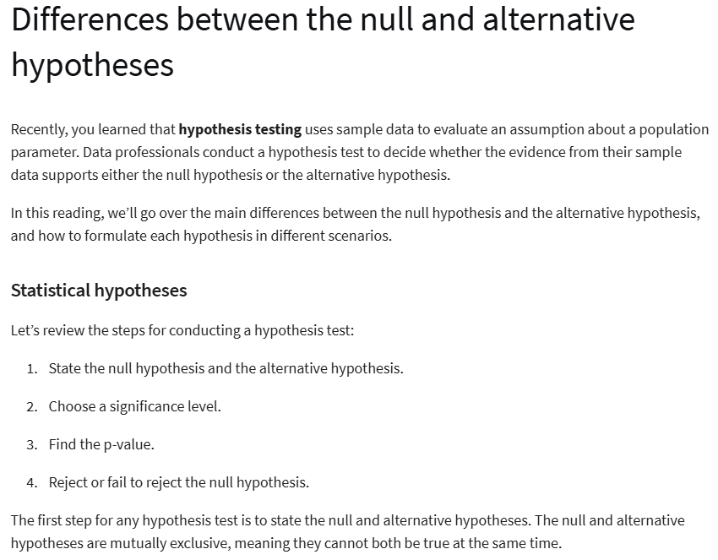



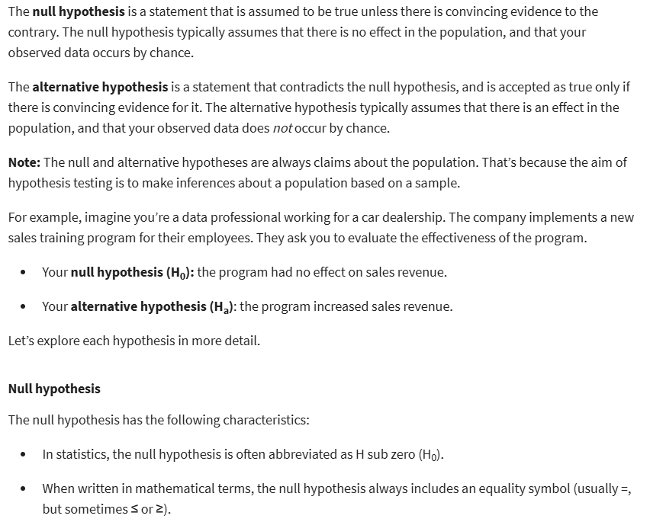



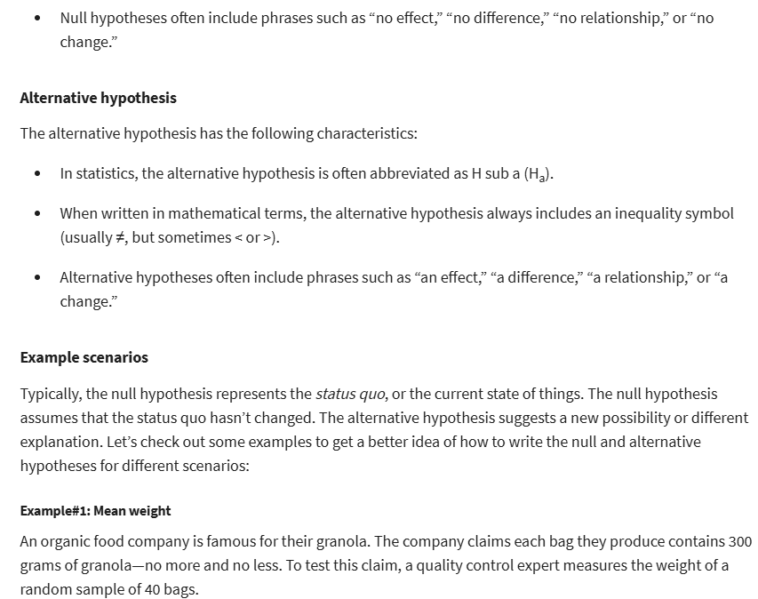



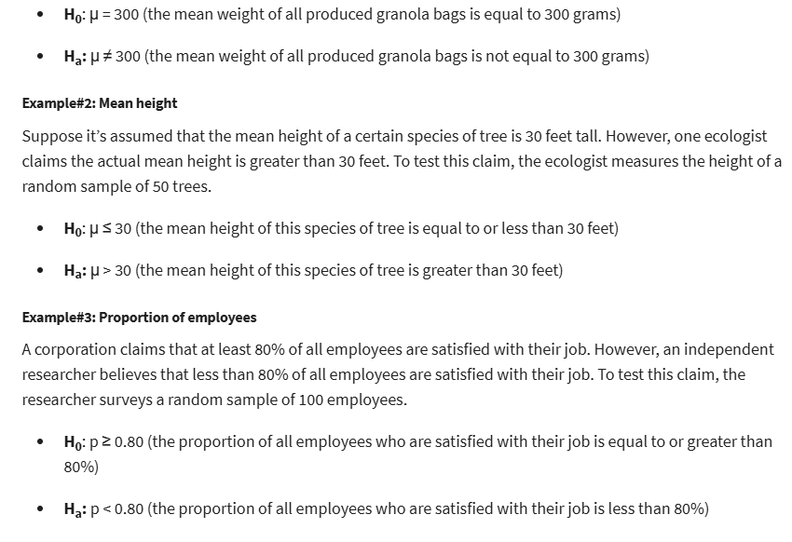

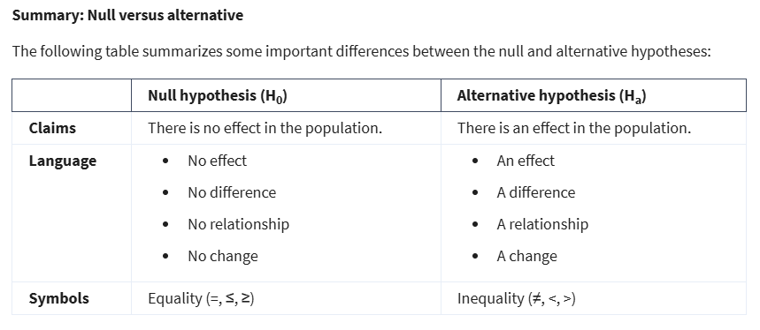



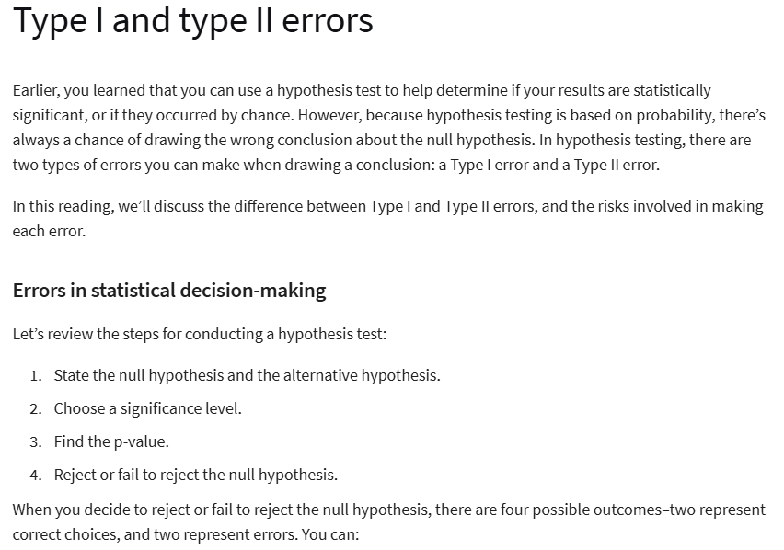



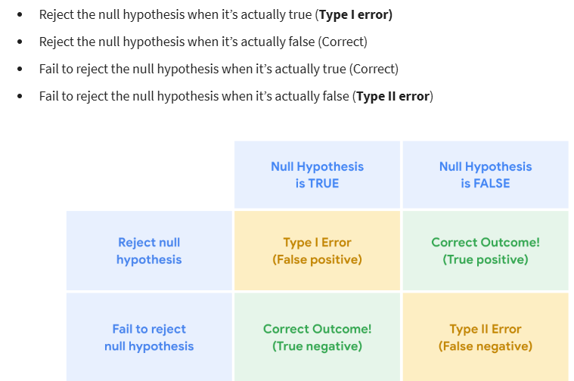

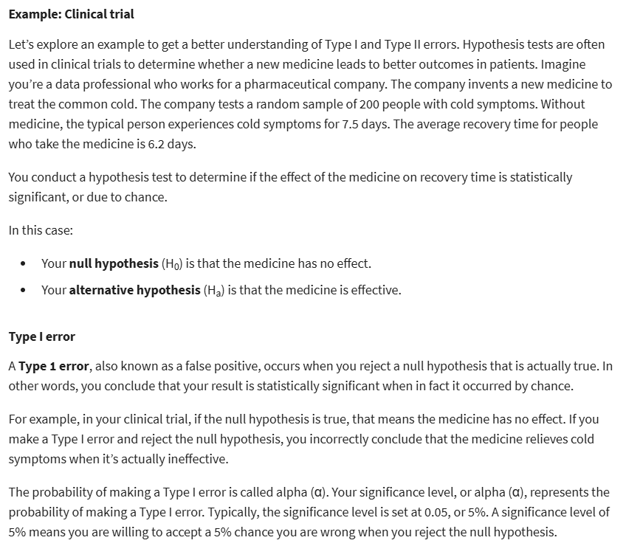

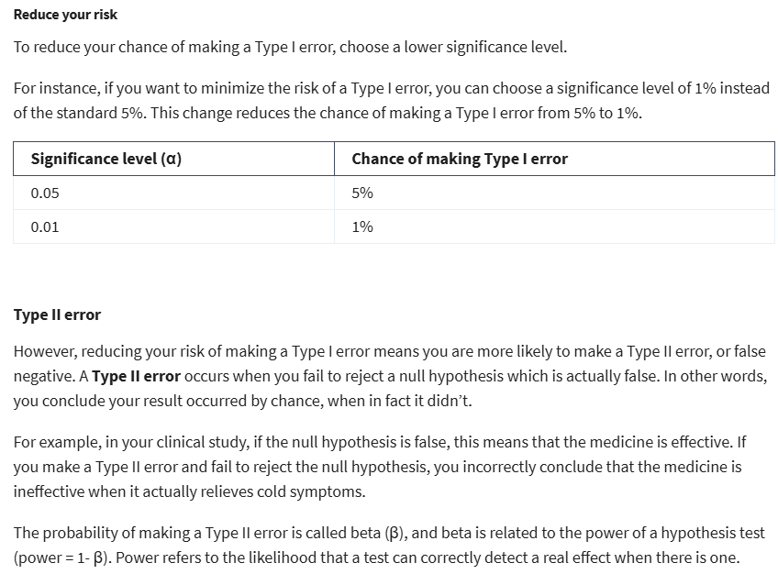



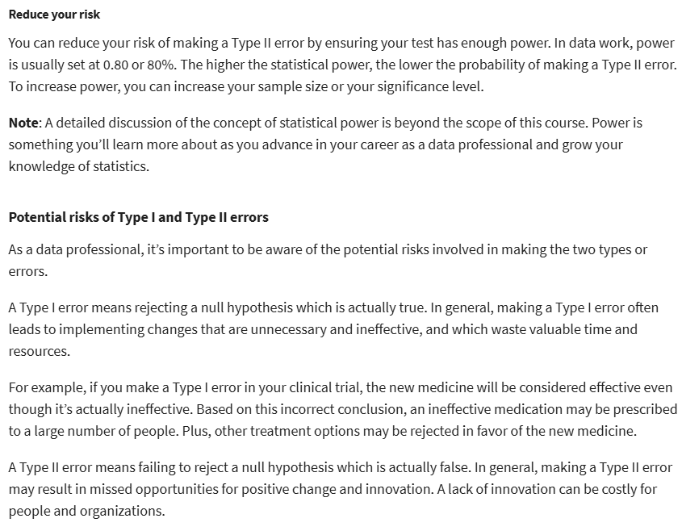



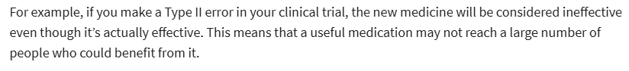

**One-sample test for means**

* One-sample test: determines whether or not **a population parameter** like a mean or proportion is **equal to a specific value**.
* Two-sample test: determines whether or not **2 population parameters** such as 2 means or 2 proportions are **equal to each other**
* One-sample z-test assumptions:
* The data is a random sample of a normally distributed population
* The population standard deviation is known
* Test statistic: a value that shows how closely your observed data matches the distribution expected under the null hypothesis.

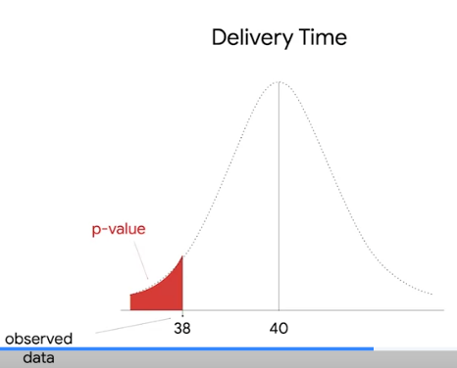

* Z-score: a measure of how many std deviations below and above the population mean a data point is

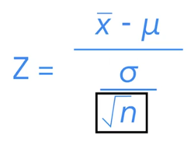

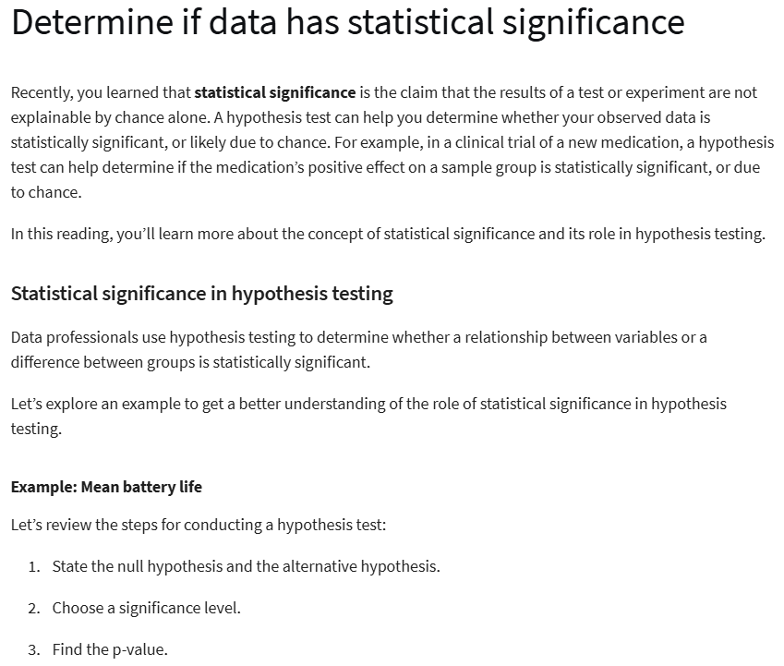

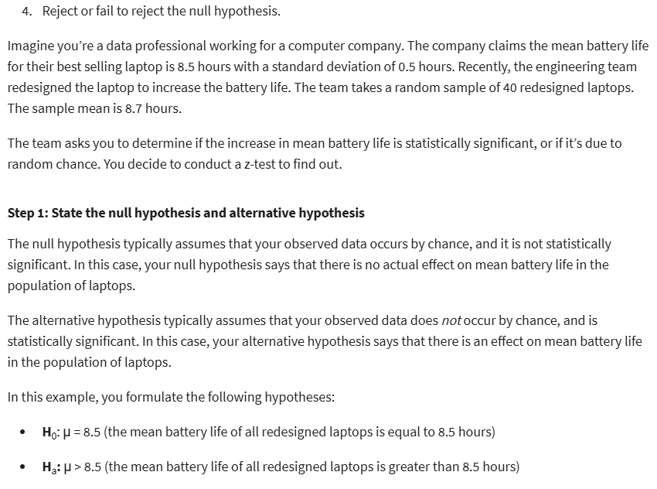

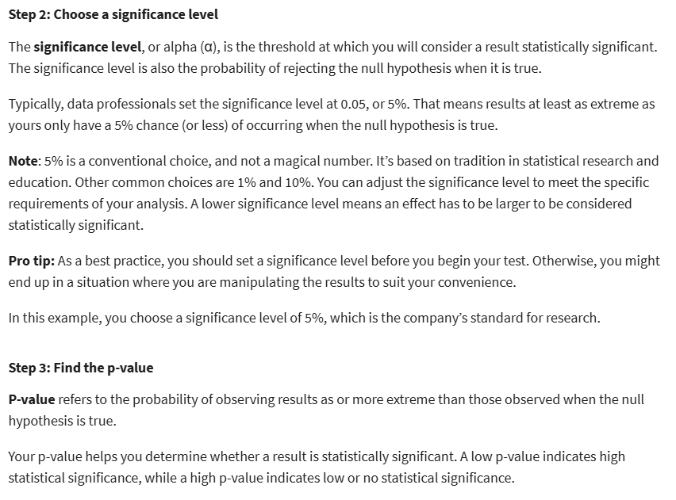

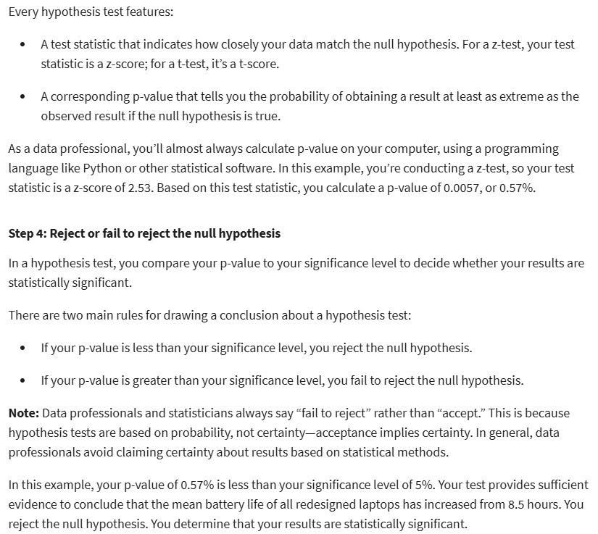

Two-sample tests: **Mean**

* Assumptions:
* The two samples are **independent** of each other
* For each sample, the **data is drawn randomly from a normally distributed population**
* The population **standard deviation is unknown**

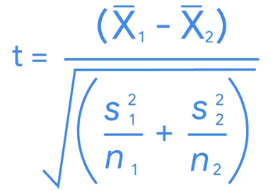

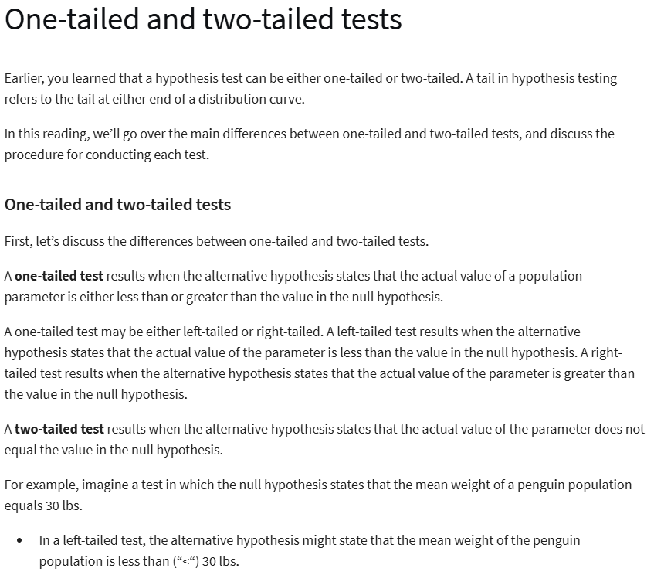

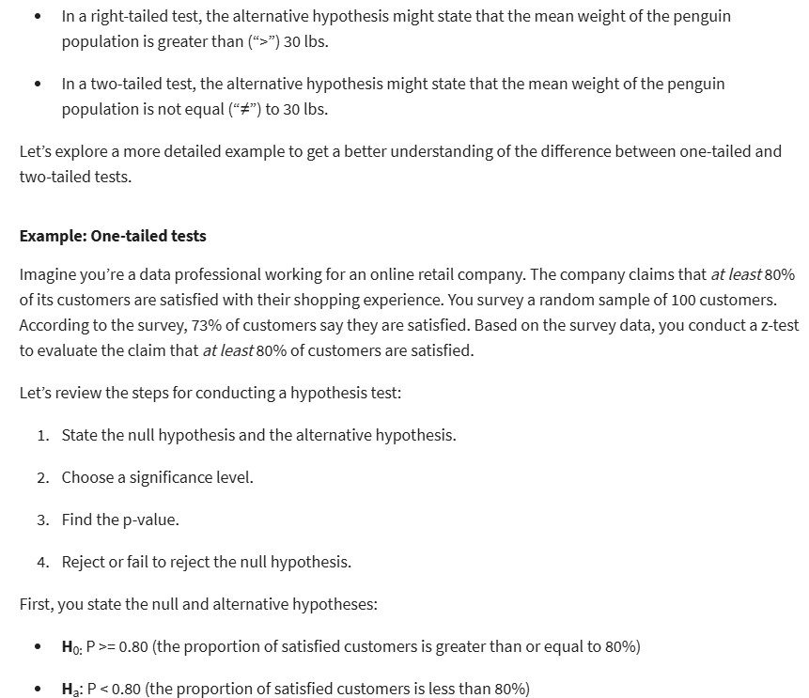

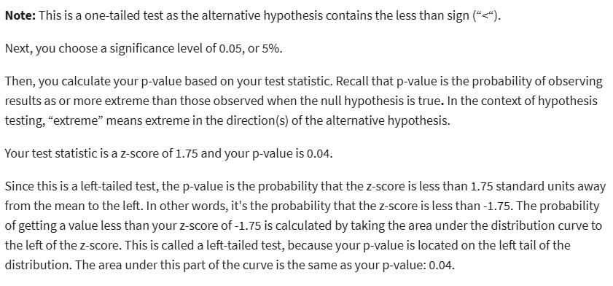

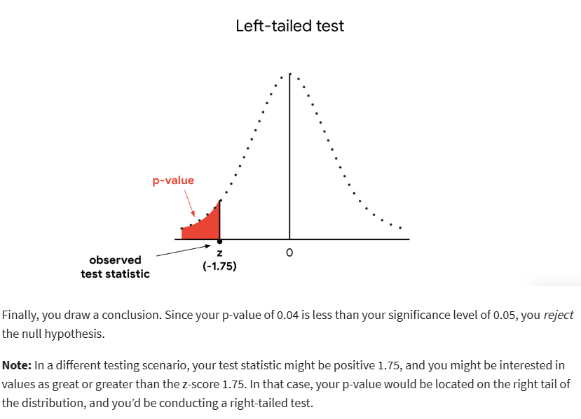

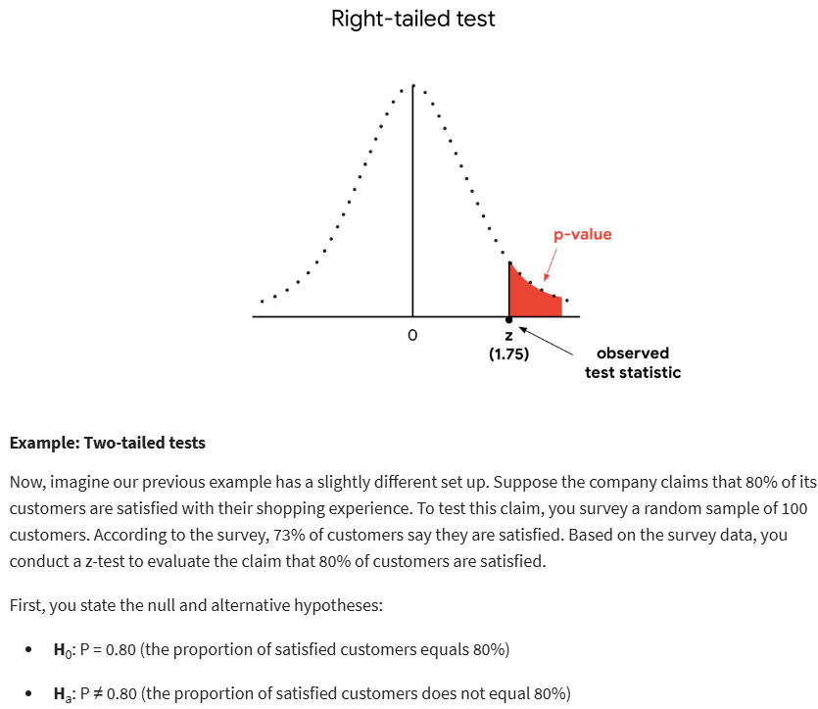

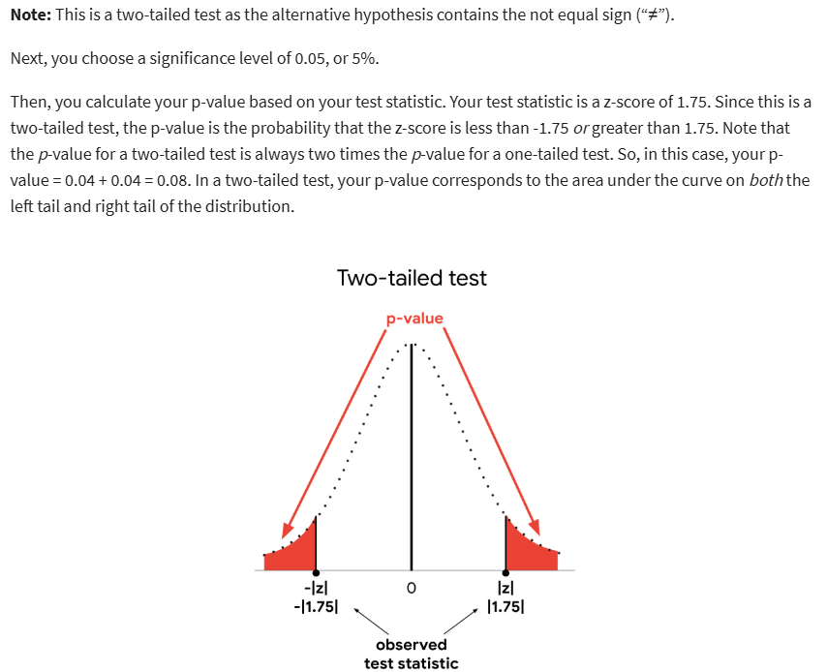

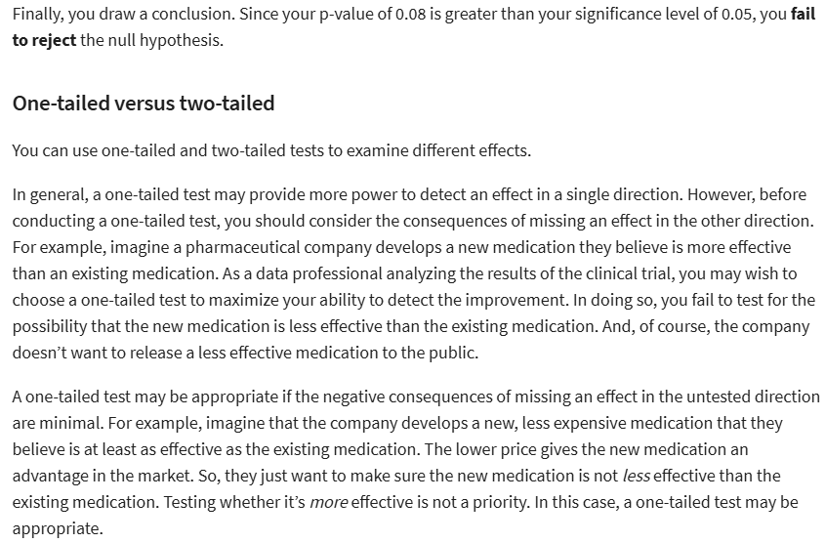

**Two-sample tests: Proportions**

1.2

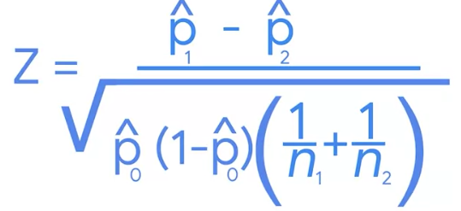

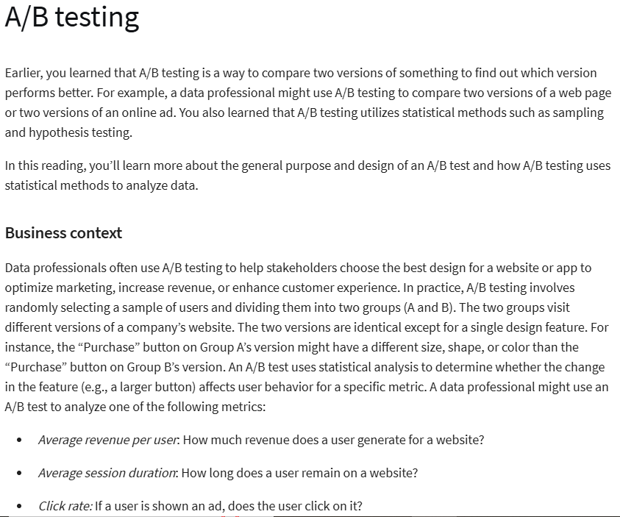

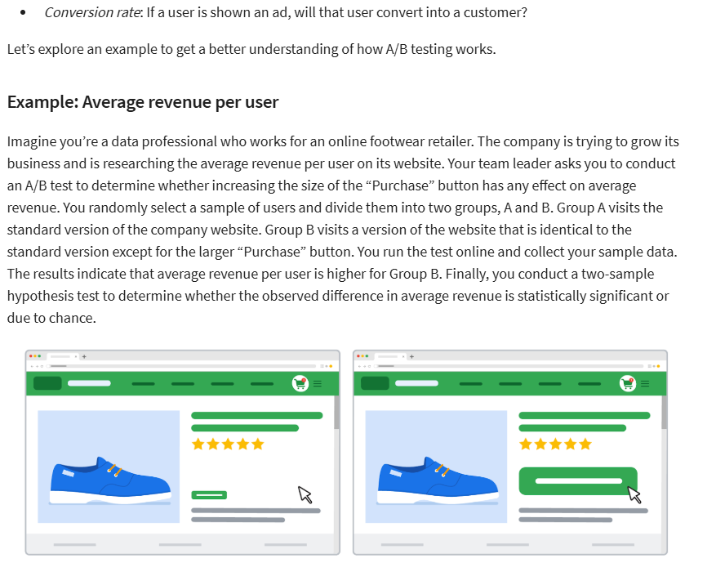

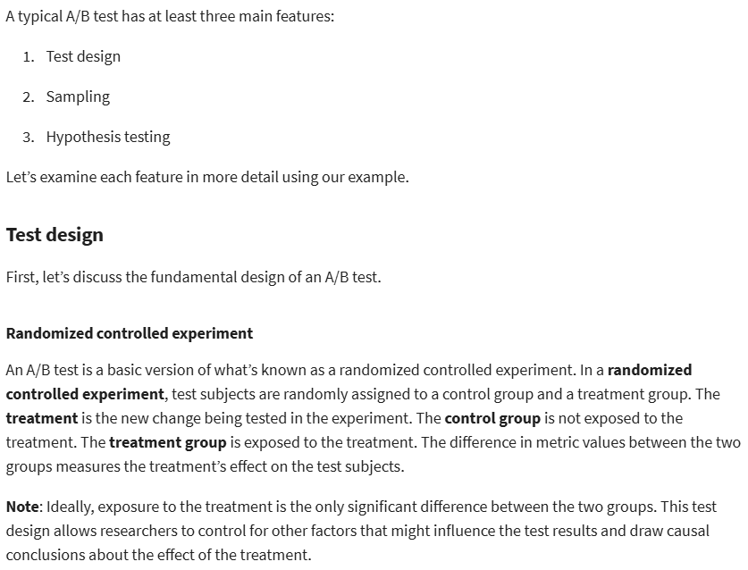

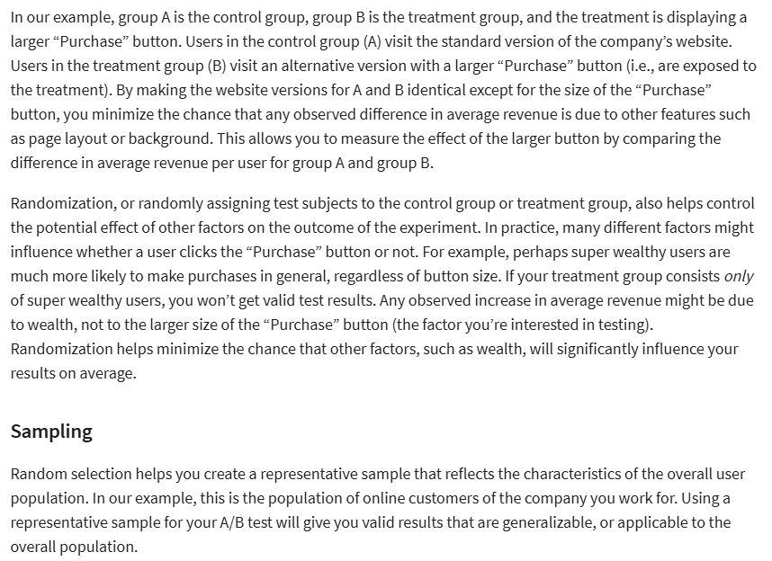

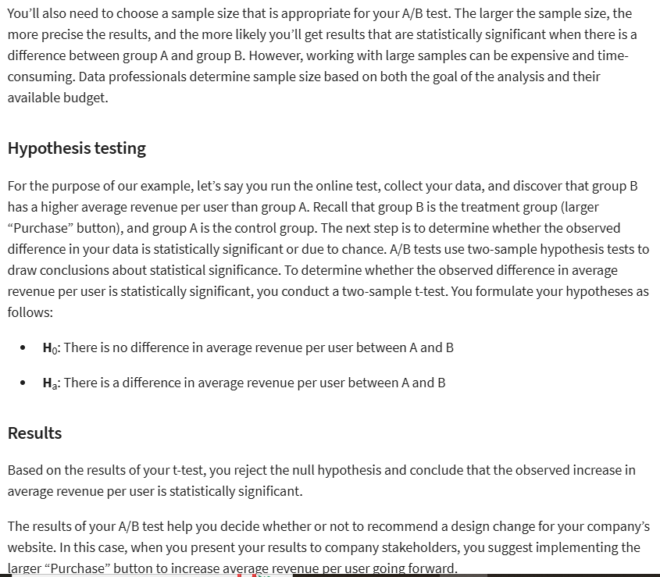

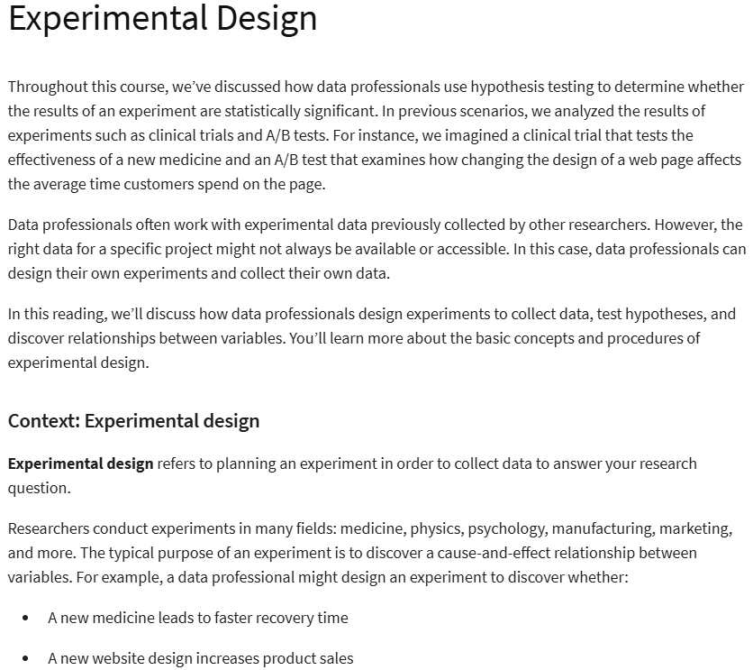

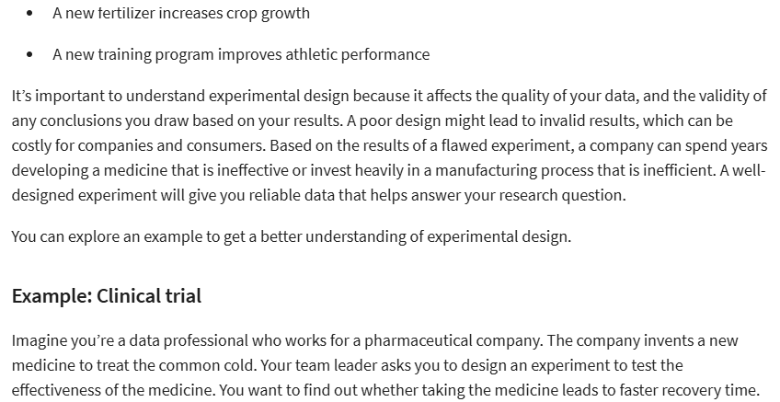

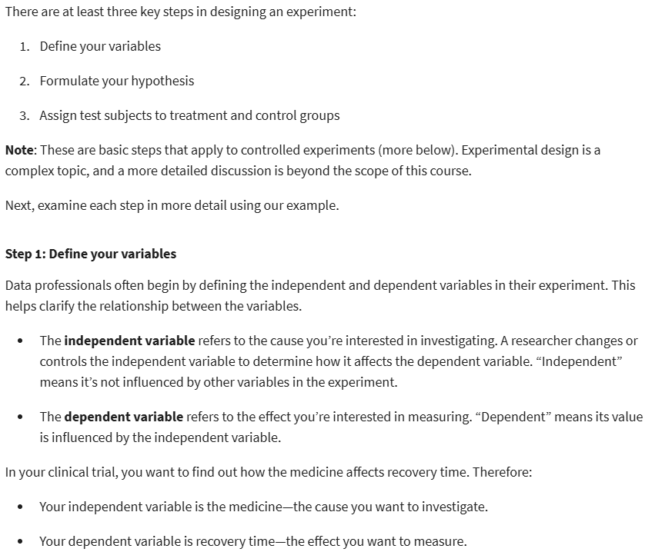

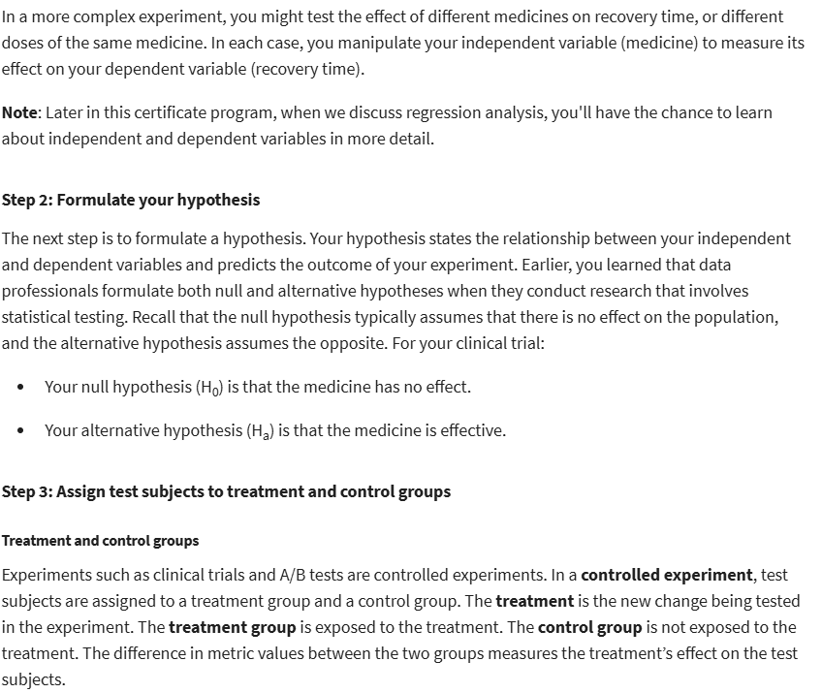

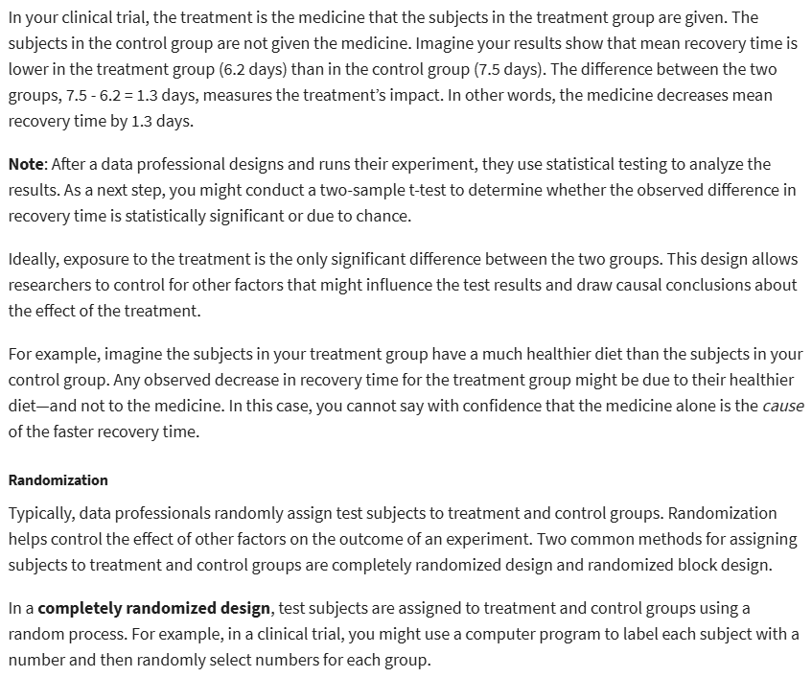

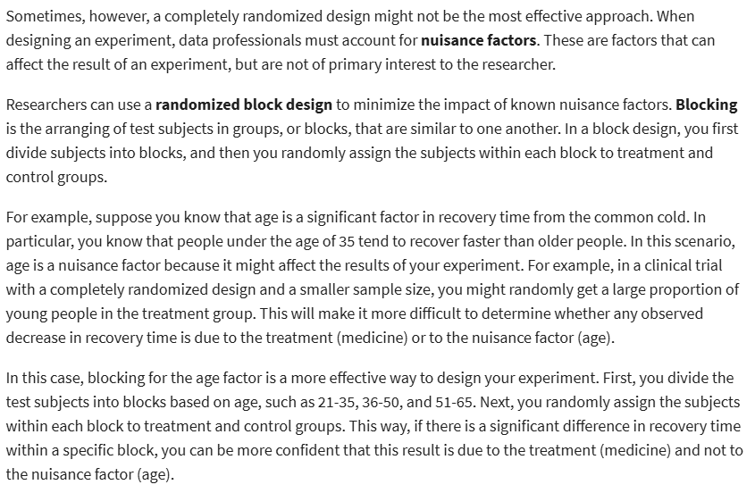

**Use Python to conduct a Hypothesis test**

